Directions: Using Google, search the definitions for absolute and relative locations and how they are used to assist geographer’s in the study of Earth’s surface. Then complete the charts that demonstrate examples of Absolute and Relative location.
Absolute Location: _______________________________________________________________________________________________________________________________________________________________________________________________________________________
Relative Location: _______________________________________________________________________________________________________________________________________________________________________________________________________________________

Landmark | City | Absolute Location | Landmark | City | Absolute Location
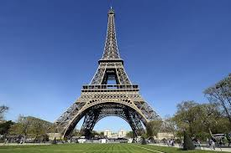  Eiffel Tower |  |  | 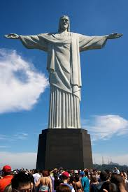  Christ the Redeemer
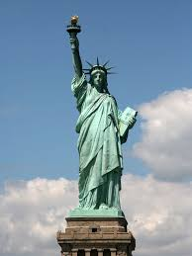  Statue of Liberty |  |  | 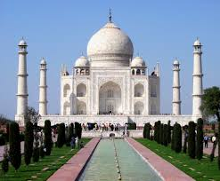  Taj Mahal
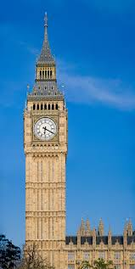
Big Ben

Pro Sports Team | City | Relative Location
Arizona Cardinals
Golden State Warriors
FC Barcelona
Toronto Maple Leafs

