Directions: The first thing you need to do is use a device and Google your term plus the word ‘definition’. Then, you will need to write a complete sentence that uses the word correctly! Enjoy your learning and this is due at the END OF THE TIMED PERIOD!
Vocabulary Term: | Definition: | Sentence Use:
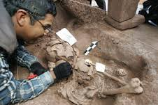  Archaeology  (ar-chae-o-lo-gist) |  | - Archaeology uses scientific methods and artifacts to study prehistory, a time when there are no written records.  - Archaeology studies customs and social norms in order to help modern citizens rewrite history.
Anthropology  (an-thro-po-lo-gy) |  | - Anthropology is a boutique that sells mass produced clothing and home décor that is very popular with college students.  - Archaeology studies customs and social norms in order to help understand past societies through history.
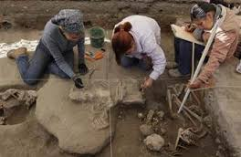  Excavation  (ex-ca-va-tion) |  | - Archaeologists excavate ancient sites to learn more about how humans development.  - Contractors excavate sturdy land in order to build foundations for parking lots and buildings.
Carbon Dating  (car-bon da-ting) |  | - Carbon dating is accurate for objects no more than about 50,000 years old.  - Carbon dating happens when two carbon atoms genetically multiply.
Hominid  (ho-mi-nid) |  | - A hominid is the type of skull that early humans had to account for their more advanced brains.  - Lucy was the name given to the 4,000 year old skeleton of a hominid found in the 1970s.
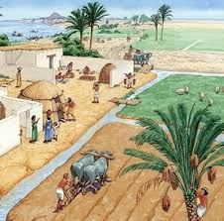  Neolithic Revolution  (ne-o-li-thic re-vo-lu-tion) |  | - One of the most identifiable results of the Neolithic Revolution is the rise of permanent human settlements.  - One of the most identifiable result of the Neolithic Revolution is independence achieved by the colonies.
Filial Piety  (fi-li-al pi-e-ty) |  | - Filial piety, the act of honoring your family, is most closely associated with Daoism.  - Filial piety, the act of having many children, is most closely associated with Protestantism.
Monsoon  (mon-soon) |  | - Many areas in the Southwest United States experience monsoon weather patterns for a long period of time.  - Many areas in Southeast Asia experience monsoon weather patterns for months at a time.
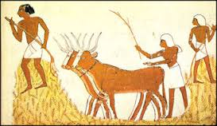  Agriculture  (ag-ri-cul-ture) |  | - 4H clubs and the FFA emphasize learning about agriculture as a way to sustain homes, families, and businesses.  - Business Professionals Of America emphasizes learning about agriculture as a way to make millions of dollars in an ethical manner.
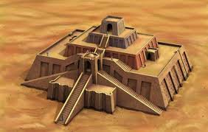  Ziggurat  (zig-gu-rat) |  | - A ziggurat was a natural-formed pyramid that was used to worship Mesopotamian gods.  - A ziggurat was man-made structure that was used to worship Mesopotamian gods.
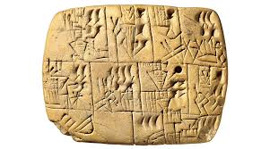  Cuneiform  (cu-nei-form) |  | - Cuneiform was used as a form of record-keeping in ancient history.  - Cuneiform is the code of symbols used to tell computers how to operate.
Bureaucracy  (bu-re-au-cra-cy) |  | - Bureaucracy is made up of individuals who run any type of human organization with daily tasks and goals to accomplish.  - Bureaucracy is the upper class of wealthiest males who run the government because the king tells them to.
Sanskrit  (san-skrit) |  | - Sanskrit is an ancient language that died out thousands of years ago that no one can decipher or understand today.  - Sanskrit is an ancient language that many people in India can still read today because they are followers of Hinduism.
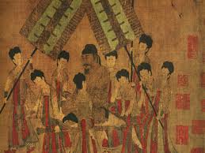  Dynasty  (dy-nas-ty) |  | - Dynasty was a popular TV show about many generations of the same family that aired during the 1980s.  - Many Chinese families took power for hundreds of years at a time, creating a dynasty named after them.

