DIRECTIONS: Use Google to identify the important details, achievements, and annotations about each historical figure from the Classical Civilizations listed below. Remember- avoid using Wikipedia!

Historical Figure | Annotations
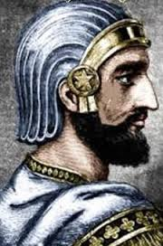  Darius the Great  Empire: ______________________ | Time Period: ______________________________________  Achievements: ____________________________________________________________________________ ______________________________________________________________________________________________ ______________________________________________________________________________________________ ______________________________________________________________________________________________  Notes: ______________________________________________________________________________________  ______________________________________________________________________________________________  ______________________________________________________________________________________________
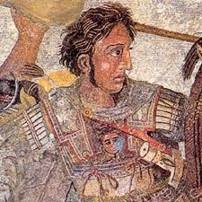  Alexander the Great  Empire: ______________________ | Time Period: ______________________________________  Achievements: ____________________________________________________________________________ ______________________________________________________________________________________________ ______________________________________________________________________________________________ ______________________________________________________________________________________________  Notes: ______________________________________________________________________________________  ______________________________________________________________________________________________  ______________________________________________________________________________________________
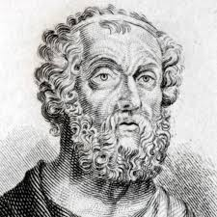  Homer  Empire: ____________________ | Time Period: ______________________________________  Achievements: ____________________________________________________________________________ ______________________________________________________________________________________________ ______________________________________________________________________________________________ ______________________________________________________________________________________________  Notes: ______________________________________________________________________________________  ______________________________________________________________________________________________  ______________________________________________________________________________________________
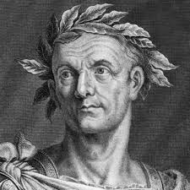  Julius Caesar  Empire: _____________________ | Time Period: ______________________________________  Achievements: ____________________________________________________________________________ ______________________________________________________________________________________________ ______________________________________________________________________________________________ ______________________________________________________________________________________________  Notes: ______________________________________________________________________________________  ______________________________________________________________________________________________  ______________________________________________________________________________________________
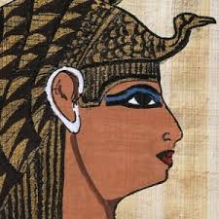  Cleopatra  Empire: ______________________ | Time Period: ______________________________________  Achievements: ____________________________________________________________________________ ______________________________________________________________________________________________ ______________________________________________________________________________________________ ______________________________________________________________________________________________  Notes: ______________________________________________________________________________________  ______________________________________________________________________________________________  ______________________________________________________________________________________________
Glue Here (Page 2)
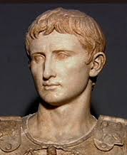  Caesar Augustus  Empire: _____________________ | Time Period: ______________________________________  Achievements: ____________________________________________________________________________ ______________________________________________________________________________________________ ______________________________________________________________________________________________ ______________________________________________________________________________________________  Notes: ______________________________________________________________________________________  ______________________________________________________________________________________________  ______________________________________________________________________________________________
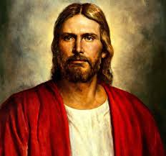  Jesus of Nazareth  Empire: ____________________ | Time Period: ______________________________________  Achievements: ____________________________________________________________________________ ______________________________________________________________________________________________ ______________________________________________________________________________________________ ______________________________________________________________________________________________  Notes: ______________________________________________________________________________________  ______________________________________________________________________________________________  ______________________________________________________________________________________________
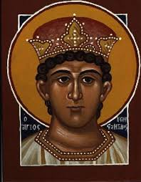  Constantine I  Empire: __________________ | Time Period: ______________________________________  Achievements: ____________________________________________________________________________ ______________________________________________________________________________________________ ______________________________________________________________________________________________ ______________________________________________________________________________________________  Notes: ______________________________________________________________________________________  ______________________________________________________________________________________________  ______________________________________________________________________________________________
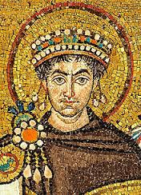  Justinian  Empire: _________________ | Time Period: ______________________________________  Achievements: ____________________________________________________________________________ ______________________________________________________________________________________________ ______________________________________________________________________________________________ ______________________________________________________________________________________________  Notes: ______________________________________________________________________________________  ______________________________________________________________________________________________  ______________________________________________________________________________________________
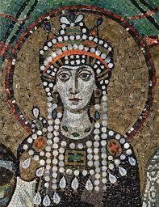  Theodora  Empire: __________________ | Time Period: ______________________________________  Achievements: ____________________________________________________________________________ ______________________________________________________________________________________________ ______________________________________________________________________________________________ ______________________________________________________________________________________________  Notes: ______________________________________________________________________________________  ______________________________________________________________________________________________  ______________________________________________________________________________________________
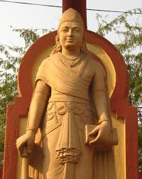  Chandragupta Maurya  Empire: ____________________ | Time Period: ______________________________________  Achievements: ____________________________________________________________________________ ______________________________________________________________________________________________ ______________________________________________________________________________________________ ______________________________________________________________________________________________  Notes: ______________________________________________________________________________________  ______________________________________________________________________________________________  ______________________________________________________________________________________________
Glue Here (Page 3)
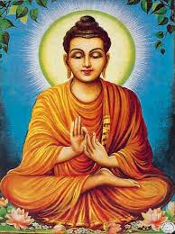  Siddhartha Gautama  Empire: ____________________ | Time Period: ______________________________________  Achievements: ____________________________________________________________________________ ______________________________________________________________________________________________ ______________________________________________________________________________________________ ______________________________________________________________________________________________  Notes: ______________________________________________________________________________________  ______________________________________________________________________________________________  ______________________________________________________________________________________________
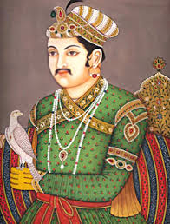  Chandra Gupta I  Empire: ____________________ | Time Period: ______________________________________  Achievements: ____________________________________________________________________________ ______________________________________________________________________________________________ ______________________________________________________________________________________________ ______________________________________________________________________________________________  Notes: ______________________________________________________________________________________  ______________________________________________________________________________________________  ______________________________________________________________________________________________
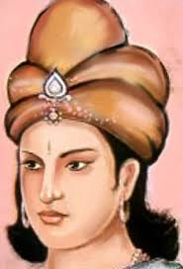  Asoka  Empire: ___________________ | Time Period: ______________________________________  Achievements: ____________________________________________________________________________ ______________________________________________________________________________________________ ______________________________________________________________________________________________ ______________________________________________________________________________________________  Notes: ______________________________________________________________________________________  ______________________________________________________________________________________________  ______________________________________________________________________________________________
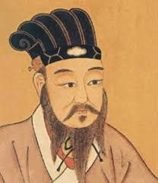  Confucius  Empire: ___________________ | Time Period: ______________________________________  Achievements: ____________________________________________________________________________ ______________________________________________________________________________________________ ______________________________________________________________________________________________ ______________________________________________________________________________________________  Notes: ______________________________________________________________________________________  ______________________________________________________________________________________________  ______________________________________________________________________________________________
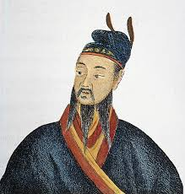  Qin Shi Huang  Empire: ___________________ | Time Period: ______________________________________  Achievements: ____________________________________________________________________________ ______________________________________________________________________________________________ ______________________________________________________________________________________________ ______________________________________________________________________________________________  Notes: ______________________________________________________________________________________  ______________________________________________________________________________________________  ______________________________________________________________________________________________
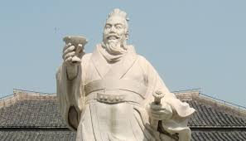  Liu Bang  Empire: ___________________ | Time Period: ______________________________________  Achievements: ____________________________________________________________________________ ______________________________________________________________________________________________ ______________________________________________________________________________________________ ______________________________________________________________________________________________  Notes: ______________________________________________________________________________________  ______________________________________________________________________________________________  ______________________________________________________________________________________________

