Positive & Negative Views of the Columbian Exchange

Positive View of the Columbian Exchange

For generations, Christopher Columbus was considered a hero of American history. He and the European explorers that followed were credited with bringing civilization to a new land. Their discoveries provided a way for Europeans to leave the continent and make new lives for themselves. While the explorers were on a quest for gold and riches, they also sought to spread Christianity and European ideals. In their view, the peoples they encountered in the New World were uncivilized and ignorant. They brought European ideas and Western religion to the continent, leading to a mixing of cultures. This diversity is still reflected in the populations of North America today. Right or wrong, the Europeans thought they were actually helping native peoples.

The Europeans also brought tools and beasts of burden that improved technology and agricultural efforts. A beast of burden is an animal, like an ox or a cow, used by humans to make the difficult work of agriculture easier. Before Columbus, the New World had never seen horses, guns, or metal tools.

Europeans also brought crops to the Americas such as wheat, barley and rice. Likewise, New World crops such as maize (corn) and potatoes had not traveled east to Europe before. This seemingly simple act had a big impact. Potatoes and corn greatly changed the way Europeans ate. Their diet became healthier, which allowed people to live longer lives. So, these American crops actually helped the population of Europe to increase. Europeans also developed a taste for cocoa and tobacco, which later became major exports to the Old World. With metal tools, wheeled carts, and horses and mules, agriculture expanded across the North American continent. Europeans established plantations devoted to sugar cane
and other crops throughout the Caribbean, Central, and South America. Most of the crop yields traveled back to Europe as cash crops. A cash crop is something grown to be sold, rather than simply grown for the farmer’s own use. Despite the hardships of the native peoples, the Columbian Exchange opened the Americas up to worldwide trade. Agricultural products continue to be a main export of South America today.

Negative View of the Columbian Exchange: Diseases

When Columbus and other European explorers arrived in the New World, they knew nothing about the peoples they encountered. They did not know that Mesoamerica already had civilizations that had existed for thousands of years. There were large complex cities, written languages, and scientific knowledge. The achievements of the Inca, Maya, and Aztecs were extraordinary. Their sophisticated cities were built without the use of the wheel, iron tools, horses, or mules. The Inca, for example, developed methods to farm on steep slopes and sophisticated irrigation technology. The Aztec city of Tenochtitlán was built on water and land with stone pyramids and floating farms called chinampas. Hernán Cortés and his soldiers wrote back to Europe in 1521 expressing their admiration. However, the majestic city would soon lay in ruins as the Aztecs fought to defend their empire - and lost. The story is similar across the Americas.

Europeans did bring new technologies and animals such as horses, cattle, sheep, and goats. However, those improvements came at a high price. The conquistadors (Spanish invaders) destroyed religious temples, killed those who refused to convert to Christianity, and forced natives into slavery. Cities were destroyed and cultural artifacts were lost forever. Although the Europeans were outnumbered, their sophisticated weaponry gave them an advantage. Guns traded to indigenous peoples also increased the death toll among tribes fighting amongst one another, especially in North America.

More than guns, the most devastating result of the Columbian Exchange was the spread of disease. In the years following European invasion, it is estimated that up to 95 percent of the Americas’ total population died. That’s roughly 20 million people. The main cause of death was disease, such as smallpox, malaria, and influenza. These diseases did not exist in the New World prior to the European’s arrival. Because the native peoples had no natural immunity, they became sick. Europeans were less affected by disease outbreaks because they had been exposed to the germs before. There was also little understanding of disease and how to contain outbreaks. Diseases spread rapidly.

Negative View of the Columbian Exchange: African Slave Trade

Because there was very little understanding of disease, the Europeans thought the native peoples were weak and sickly. Huge numbers of the native populations were wiped out from diseases, which led to a big shortage of labor. Europeans quickly realized that they could not build a workforce out of the native peoples. The Europeans needed manual labor for the agricultural enterprises they set up, so they turned to the African slave trade. Beginning in the 1500s, thousands upon thousands of enslaved Africans were shipped to the continent.

In fact, the majority of enslaved Africans ended up in the Caribbean, Central America, and South America—ultimately almost 12 million. Approximately 500,000 were shipped to North America. Current economic hardships and social injustices today can still be traced back to the period of European domination. For example, native populations all over the North American continent struggle with issues of poverty and lack of opportunities. While there are still some Incan, Mayan, Aztec, and Native American cultures that remain today, many continue to struggle some 500 years after Columbus.
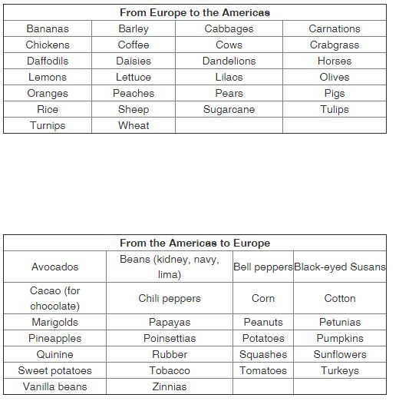
Weighing the Good and Bad

Columbus was just the first in a long line of explorers and conquerors. His voyage opened the door to European conquest of the Americas. Traditional Western history taught that Columbus was a hero. His arrival brought European goods and ideas that could help improve civilization in the Americas. The impact on native peoples was downplayed. However, today, we know that there was much more to the story. While some still consider Columbus a hero, others see him as a villain. Though there were positive effects, the Columbian Exchange had a long-lasting negative impact.

New technologies, a mingling of cultures, and the exchange of plants may well be positive outcomes of the Columbian Exchange. Do those positives outweigh the staggering death toll and the introduction of slavery to the continent? Perhaps the answer is that the Columbian Exchange was both good and bad. More than 500 years after Columbus’s arrival, we are able to have new perspectives and insight on what happened in the past. The world would certainly be a very different place if the Old World and New World had never met.

