Positive & Negative: The Columbian Exchange
DIRECTIONS: Use your reading “Positive & Negative Views of The Columbian Exchange” and complete the answers below. Then, use Google Image search to find photos of products that were exchanged between Europe and the Americas. (Use blue print for your answers)
1. What were some of the positive outcomes of the Columbian Exchange?

2. What were some of the negative outcomes of the Columbian Exchange?

3. What were some of the products exchanged between Europe & the Americas?
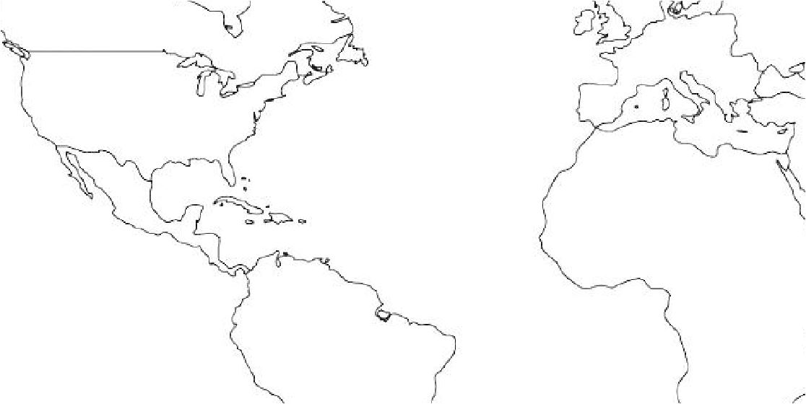

Items sent to the Americas from Europe
Items Sent to Europe from the Americas

