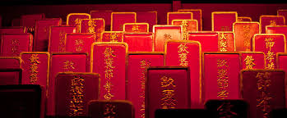

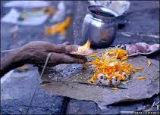
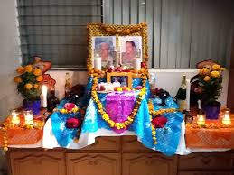

Culture in Asia

I. Ancestor Veneration
A. China
1. Ancestor Veneration, or the honoring of deceased family members, is an important part of Chinese life.
2. When a person dies the Chinese believe that their soul enters an ancestral tablet (like a headstone).
~The tablet is placed in a family shrine where they burn incense and make offerings.
3. April 5 is Tomb Sweeping Day, where families clean and decorate the tombs and shrines of family members, often bringing food and offerings.
4. The Chinese believe that the dead also have the ability to create good and bad luck for their descendants, based on how they have been honored.
B. India
1. Pitri-Paksha is a period of time, about 15 days, where Hindus remember their ancestors.
~Hindus will donate food to the hungry, in hopes that their ancestors will also be fed.
2. Vedic (sacred text) states that an individual is born with 3 debts.
~The 3rd is to remember your parents, and everything you do should only bring fame and glory to their name.
C. Philippines
1. Most people in the Philippines are Roman Catholic due to Spanish colonization starting in the 1500’s.
2. Commonly, ancestor veneration is shown by having a home altar with pictures of people who have passed away.
3. They also believe that dead parents act as a guide to the livings future afterlife.
4. Providing the dead with some of their ‘favorites’ like drinks, foods, etc. will encourage them to bring you into the afterlife.

Color in China in Yellow
Color in India in Blue
Color in the Philippines in Purple
Name_______________________________________________________ Date:_____________________Period:___________

Culture in Asia

I. Ancestor Veneration
A. China
1._______________________________, or the honoring of ________________________ family members, is an important part of __________________________life.
2. When a person dies the Chinese believe that their _______________________enters an _______________________________(like a headstone).
~The tablet is placed in a _____________________________where they burn ________________ and make______________________.
3. ____________________is Tomb Sweeping Day, where families _____________and ________________ the tombs and shrines of family members, often bringing ________and____________________.
4. The Chinese believe that the dead also have the ability to create ___________and ____________ luck for their descendants, based on how they have been ______________________.
B. India
1. ____________________________is a period of time, about ________days, where __________________ remember their ancestors.
~Hindus will donate _____________to the___________, in hopes that their ancestors will also be_________________.
2. ___________________(sacred text) states that an individual is born with____________________.
~The 3rd is to_______________________________________, and everything you do should only bring ____________and _______________________to their name.
C. Philippines
1. Most people in the _____________________________are ______________________________________ due to Spanish colonization starting in the 1500’s.
2. Commonly, ___________________________________is shown by having a ___________________________ with pictures of people who have_____________________________.
3. They also believe that ___________________________act as a _____________________to the livings_____________________________________.
4. Providing the dead with some of their ‘_____________________’ like drinks, foods, etc. will encourage them to bring________________________________________.
Color in China in Yellow
Color in India in Blue
Color in the Philippines in Purple

1. What are some of your families traditions that you practice and follow each year?
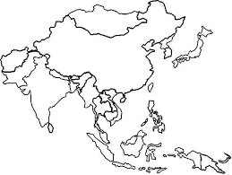

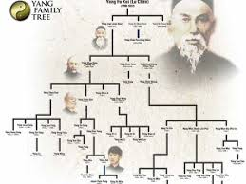
Chinese Family Tree

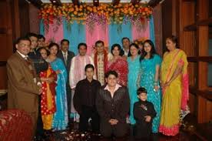
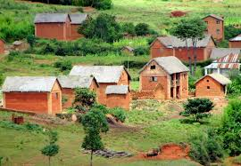

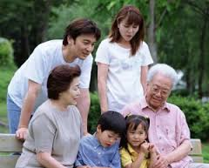

Family Structure
2. Family Structure
A. China
1. Chinese families are composed of 3 generations.
~Grandparents, Parents, and children
2. Elder members are greatly respected because they carry wisdom of the past.
3. Younger members are expected to listen, learn, and respect all elder members.
4. The grandfather (or eldest male) has the most authority in the household.
5. All generations assist in raising children, but it is the primary responsibility of the parents to teach respect, manners, and discipline.
6. Boys have been valued more than girls, since girls will marry and leave the families.
~ Boys will stay and take care of parents and add money to the family.
B. India
1. Indian families are traditionally ‘joint families’.
~Elderly parents, all children, children’s spouses, and offspring
2. Oldest male member is head of the household.
3. Due to urbanization, family structure is changing- Now just parents and their children.
~No longer financially practical to have all members of a family in one house
C. Indonesia
1. Common for extended families to live in one area, although less common in big cities
~Grandparents, Aunts, Uncles, Cousins
2. Indonesians are expected to follow the advice and teachings of their elders.
3. Newly married couples often live with the wife’s parents for a few years, then move
to a home not far from the family establishment.
~Children will assist the older generations as they age

Name_______________________________________________________ Date:_____________________Period:___________

Family Structure
2. Family Structure
A. China
1. Chinese families are composed of_______________________________________.
~Grandparents, Parents, and children
2. __________________________are greatly respected because they ____________________________ _____ of the past.
3. _________________________members are expected to__________________, ________________, and ________________________ all elder members.
4. The grandfather (or_____________________________) has the most authority in the household.
5. All generations assist in__________________________________, but it is the primary responsibility of the ___________________to teach________________, ______________, and______________________.
6. __________________have been _____________________more than ________________________, since girls will marry and leave the families.
~ _____________________and _____________________________ and add money to the family.
B. India
1. Indian families are traditionally ‘_______________________________’.
~Elderly parents, all children, children’s spouses, and offspring
2. _________________________________________is head of the household.
3. Due to________________________________, family structure is changing- Now just parents and their children.
~No longer ___________________practical to have all members of a family in one house
C. Indonesia
1. Common for _________________________to live in one________________, although less common in big cities
~Grandparents, Aunts, Uncles, Cousins
2. Indonesians are expected to follow the _________________________________of their elders.
3. ___________________________ couples often live with the ______________________________for a few years, then move.
to a home ________________________from the_________________________________.
~Children will assist the _________________________________as they age

In the space below, draw your family tree based on Asian cultural traditions. | Color China Green  Color India Orang  Color Indonesia Red
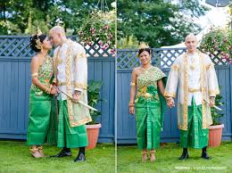
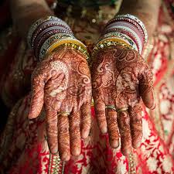
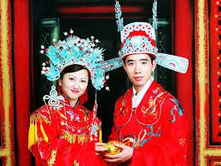

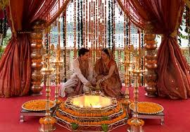

Weddings and Marriage Ceremonies
3. Weddings and Marriage Ceremonies
A. China
1. Historically, Chinese parents arranged their children’s marriages, and it was common for the bride and groom to meet on their wedding day.
2. Today, picking your spouse is more common, but parents still play a large role in bringing couples together.
3. Parents arrange a formal meeting, Xiang Qin, and visit with an astrologer to see when the best time for marriage would be.
4. On the day of the wedding, the Groom eats with the bride at her parents house, then they go to the grooms house for the wedding.
5. The bride usually wears red, while the groom wears dark colors.
~They will burn incense and family members will give money in red envelopes
B. India
1. Indian marriages are still predominately arranged, while some couples are participating in ‘love marriages’.
2. The ceremonies are structured into three parts:
~Pre- Wedding: Bride decorating her Sari with gold and diamonds, painting hands and feet
~Wedding: Bride sits on the right side of the groom, then on the left to signify their unity
~Post Wedding: (Vidaii) Bride leaves her fathers house and joins her husband
C. Cambodia
1. Choice of spouse is complex, as a male involves his family and friends.
2. Consult a matchmaker and fortuneteller to help find a wife.
~Women can veto men who have been ‘matched’ to them
3. Last daughter to be married is expected to stay with family and take care of parents.
4. Traditional weddings are long and colorful, lasting a day and a half.
~Hair cutting, tying cotton threads in holy water, passing candles, and having respected married couples bless the new couple

Name_______________________________________________________ Date:_____________________Period:___________
Weddings and Marriage Ceremonies
3. Weddings and Marriage Ceremonies
A. China
1. Historically, Chinese parents _________________________their children’s marriages, and it was common for the bride and groom to____________________________________.
2. Today, ____________________your spouse is more___________________________, but parents still play a _________________________role in bringing couples together.
3. Parents arrange a_____________________________, Xiang Qin, and visit with an __________________ to see when the best time for marriage would be.
4. On the day of the wedding, the ________________________with the bride at her parents house, then they go to the _____________________________for the wedding.
5. The bride usually wears___________________, while the groom wears ______________________.
~They will ___________________and family members will give _______________________ envelopes
B. India
1. Indian marriages are still________________________________________, while some couples are participating in ‘_________________________________’.
2. The ceremonies are structured into_______________________:
~_____________________________: Bride decorating her _____________with ______________and _______________________, painting hands and feet
~_________________________: Bride sits on the right side of the___________________, then on the left to signify their unity
~________________________: (Vidaii) Bride leaves her ___________________________and joins her husband
C. Cambodia
1. Choice of spouse is_______________________, as a male involves his _____________and________________.
2. Consult a _____________________and _____________________________to help find a wife.
~Women can _______________________men who have been ‘______________________’to them
3. Last daughter to be married is ________________________to stay with ___________________and take care of_____________________.
4. Traditional weddings are ________________and_________________, lasting a day and a half.
~Hair cutting, tying cotton threads in__________________, passing__________________, and having respected married couples ____________________________________________

Color China Brown
Color India Pink
Color Cambodia Light Blue

1. Why do you think the families of brides and grooms from the above countries are involved in picking spouses?

2. Do you think your parents could pick a spouse for you?

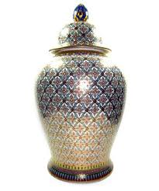
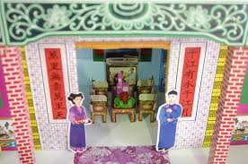
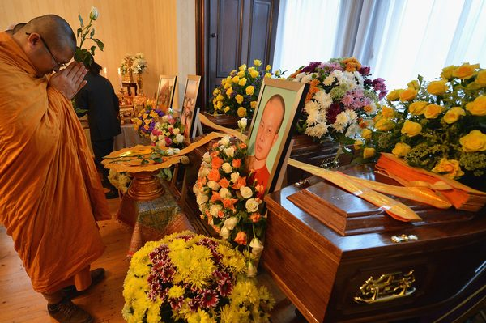

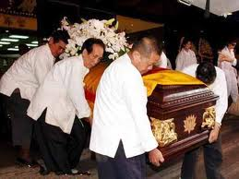
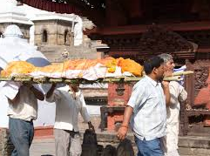

Death and Mourning

4. Death and Mourning
A. China
1. Chinese families have elaborate death ceremonies to honor relatives.
2. They place blue paper on doors to indicate a tragedy has occurred, as all deaths are tragedy’s.
~Friends bring food and money to help pay expenses
3. During the funeral, families wear white, and bow and kneel before the coffin.
4. Period of mourning for 7 weeks, where various items are made out of paper (cars, houses, clothes, etc..) as offerings to the dead to provide them with what they may need.
5. The families will regularly hold ceremonies to honor their dead relatives and ancestors.
B. India
1. Antyesti means ‘last sacrifice’, and is the term used to discuss funeral rights of Indians.
2. Adults are typically cremated, while young children who have not reached puberty are buried within a day.
~ Bodies are washed, wrapped in white cloth, have two toes tied together with a string, and a red ‘Tilak’ mark placed on the forehead
3. The eldest male member says a eulogy, and then places sesame seed or rice in the dead persons mouth, as a last offering.
4. After cremation, ashes are spread in rivers or sea, with the Ganges River being the holiest site.
C. Thailand
1. In Thailand, funerals last for a week, and crying is discouraged throughout the period.
2. Copies of Buddhist scriptures are printed and distributed, and gifts are given to local temples in the name of the deceased.
3. A best picture of the deceased is displayed to show respect.
4. Monks hold a string that is attached to the coffin, and chant with intentions to transfer merit to the deceased.
5. Bodies are cremated and then the ashes are kept in a chedi in a local temple.
Name_______________________________________________________ Date:_____________________Period:___________

Death and Mourning
4. Death and Mourning
A. China
1. Chinese families have _____________________________ceremonies to __________________relatives.
2. They place _________________________on doors to indicate a ______________________has occurred, as all deaths are tragedy’s.
~Friends bring ______________and __________________to help pay expenses
3. During the funeral, families wear___________________, and ___________________and _________________ before the coffin.
4. Period of mourning for_________________________, where various items are made out of _________________(cars, houses, clothes, etc..) as _____________________to the __________________to provide them with what they may need.
5. The families will regularly hold ____________________to ___________________their ____________________ relatives and ancestors.
B. India
1. Antyesti means ‘_________________________’, and is the term used to discuss ______________________________________ of Indians.
2. _____________________are typically____________________, while young _____________________who have not reached puberty are ____________________within a_____________.
~ Bodies are__________________, ______________in white cloth, have two toes _____________ together with a string, and a red ‘____________’ mark placed on the _____________________
3. The _____________male member says a_______________, and then _____________sesame seed or rice in the dead persons______________, as a____________________.
4. After_____________________, ashes are spread in ______________or_______________, with the ___________________________ being the holiest site.
C. Thailand
1. In Thailand, _______________last for a_________________, and __________________________ is ________________________________ throughout the period.
2. Copies of Buddhist scriptures are ________________and____________________, and gifts are given to local ______________________in the name of the___________________________.
3. A best ___________________of the deceased is displayed to show respect.
4. _____________________hold a string that is attached to the_____________________________, and chant with intentions to transfer __________________to the_________________________.
5. Bodies are ________________and then the ashes are kept in a ________________in a local______________________.

Color China Green
Color India Blue
Color Indonesia Black

1. Describe some common funeral services here in the United States.

2. Are there any similarities or only major differences.

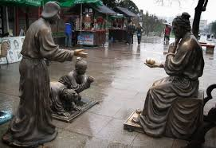
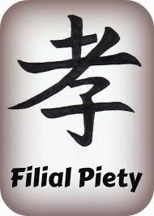

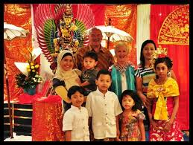
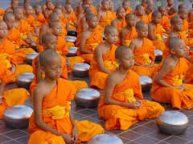

Family Relations
5. Family Relations
A. China
1. Filial Piety, devotion to and respect for ones’ elders is the most important of all Chinese virtues and disobedience is a serious offense.
2. Filial Piety states that children should obey, please, and support parents while they are alive.
3. Filial Piety has three levels:
~1st: To Honor Ones Parents Through Achievement
~2nd: Not Disgrace Oneself or Reflect Poorly on One’s Parents
~3rd: Support Ones parents through Old Age
4. Respect should be shown to all elders, and not just parents.
5. Confucius taught ‘an honorable relationship between young and old’, and that law cannot be more important than maintaining human and family relationships.
B. India
1. Strict male Buddhist followers in India actually leave their families, wives, and children to become Monks.
~Buddhist Monks have to reject all family ties, and see family as an encumbrance to mortal life as a Monk
2. Buddhism stresses Individual salvation and has little room for Confucius ideas of Filial Piety.
3. Buddhism also advocates celibacy among monks, which is the complete opposite of Chinese Filial Piety, where children are suppose to take care of elders.
C. Indonesia
1. Social values play an important part in Indonesian life.
2. ‘Saving Face’ is also extremely important.
3. Avoiding shame, and avoiding criticism of others in public and in the workplace is also important.
4. Kinship, taking care of family, is the biggest priority in Indonesia.
5. Kinship can be a burden but is vital since government and agencies do not provide: Social Security, unemployment, medical insurance, old age care, or legal help to any citizens.
~All help, if needed must come from family
Name_______________________________________________________ Date:_____________________Period:___________

Family Relations
5. Family Relations
A. China
1. _______________________, ___________________ to and _________________ for ones’ ___________________ is the most important of all Chinese virtues and _________________________________ is a ____________________ offense.
2. Filial Piety states that ____________________should ________________, _____________, and ______________________________ while they are alive.
3. Filial Piety has three levels:
~1st: To __________________ Ones _______________Through Achievement
~2nd: _______________________________ Oneself or Reflect Poorly on One’s Parents
~3rd: ______________Ones __________________through Old Age
4. ______________________should be shown to_______________________, and not just parents.
5. ________________________taught ‘an honorable relationship between young and old’, and that ______________________________________ be more important than maintaining human and ____________________ relationships.
B. India
1. Strict ___________________________________ followers in India actually ______________________their____________________, wives, and children to become Monks.
~Buddhist Monks have to____________________________________, and see family as an encumbrance to mortal life as a Monk
2. Buddhism stresses _________________________salvation and has _____________________________for Confucius ideas of Filial Piety.
3. Buddhism also advocates _________________among_____________________, which is the complete opposite of Chinese Filial Piety, where children are suppose to take care of elders.
C. Indonesia
1. _______________values play an ___________________part in Indonesian life.
2. ‘__________________’ is also _________________________important.
3.___________________________, and avoiding criticism of others in _________________________and in the ______________________________is also important.
4. Kinship, _______________________________, is the biggest priority in Indonesia.
5. ______________________can be a burden but is vital since government and agencies do not provide: Social Security, _________________________, medical______________________, old age care, or legal help to____________________________.
~All help, if needed ___________________________________________________
Color China Yellow
C Color India Orange
Color Indonesia Red

1. In your home, do you follow a system of Filial Piety?
Explain your answer with details.

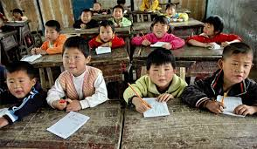
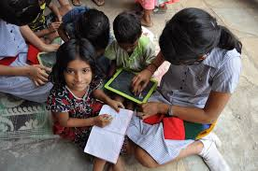
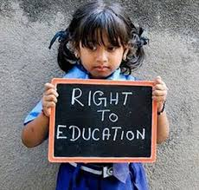

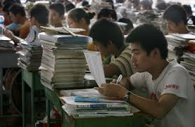
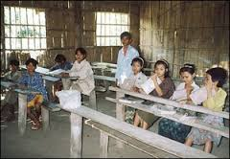

Education

6. Education
A. China
1. Historically, only wealthy landowners could afford to send their sons to school.
~Sons studied for years to pass government exams and memorize Confucian classics
2. Once these were passed, most of the boys would become government officials.
3. Peasants did not have enough money to send their children to school.
4. After the Communism ended, countryside schools were created for all.
~Taught history, reading, writing, math and agriculture
5. Countryside schools saw twice as many boys as girls.
6. Schools also taught adults to read and write.
~Literacy in villages is still only about 50% of the population
B. India
1. Education is funded by both private donations and public taxes.
~Education is provided to all (girls and boys) ages 6-14
2. Indian government has outlawed child labor in hopes of increasing schooling, but due to the difficulty in enforcing these laws, many children work instead of go to school.
3. Middle and upper class families send all children to private schools, which make up more than 50% of all schools.
4. All schools are overcrowded, and suffer with a high student to teacher ratio.
5. Historically, the ‘untouchables’ in India were not permitted to attend school, but today a certain percentage of seats must be made available to the lower class tribes of India.
C. Cambodia
1. Historically education was handled by Buddhist Monks, who taught male students chants from the holy books.
2.Once the French colonized the area, schools were improved and followed European curriculum.
~Hired trained teachers, opened more schools, allowed girls to attend
3. One the French left, educators were often tortured and killed by the new regime.
4. Since 2000, peace and stability have come back to Cambodia.’
~Elementary enrollment is 96% but Secondary enrollment is only 34%
5. Lack of funding, limited teachers, and low economies keep children at home working farms instead of in the classrooms studying.

Name_______________________________________________________ Date:_____________________Period:___________
Education

6. Education
A. China
1. Historically, only wealthy _____________________could afford to send their ________________to_____________________.
~Sons studied for years to pass _____________________________________________and ______________________________Confucian classics
2. Once these were passed, most of the boys would become__________________________________.
3. __________________did not have enough money to send their ____________________to school.
4. After the Communism ended, _________________________________were created for ___________.
~Taught history, reading, writing, math and ___________________________
5. Countryside schools saw ________________as many ____________ as _____________.
6. Schools also taught _______________ to _______________ and________________________.
~_______________ in __________________is still only about _____________ of the population
B. India
1. Education is funded by both __________________ donations and ______________ taxes.
~Education is provided to ___________ (girls and boys) ages ________________
2. Indian government has _________________________________in hopes of increasing schooling, but due to the difficulty in enforcing these laws, many children ________________________ instead of go to________________________.
3. ___________________and _________________class families send all children to _____________________ schools, which make up more than _____________________of all____________________.
4. All schools are ___________________, and suffer with a _________________to_______________________.
5. Historically, the ‘______________________’ in India were _______________permitted to attend school, but today a certain ____________________of _________________must be made _______________ to the _____________________________tribes of India.
C. Cambodia
1. Historically, education was handled by ______________________Monks, who ______________________ students chants from the ____________________ books.
2.Once the ____________________colonized the area, schools were ___________________________and followed_________________________________________.
~Hired ___________________teachers, _________________more schools, allowed __________________ to attend
3. One the _____________________ left, educators were often ________________________ and _________________ by the new regime.
4. Since 2000, _________________and _______________have come back to _____________________
~_________________ enrollment is _________but ___________enrollment is only __________
5. Lack of_______________, _______________teachers, and low ____________________________ keep children at home working _____________ instead of in the classrooms___________________.
Color China Purple
Color India Green
Color Cambodia Brown

1. Honestly think about your family and current situation. If you lived in any of these countries, would you be in school today, or working in rice fields for roughly $3.00 a day?

