Name:___________________________________________Date:____________Period:___________

Conflict: Examining the Tensions Between North & South Korea
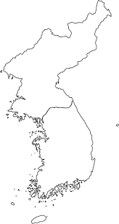
Mapping: Dividing the Korean Peninsula
North Korea is separated from South Korea by the Demilitarized Zone (DMZ). The DMZ sits at the 38° Parallel, on the Korean Peninsula.

Directions:
1. Locate, outline and label the DMZ on the map.
2. Label both North and South Korea.
3. Lightly shade them in like you would on a POLITICAL MAP.

Reading
1. Highlight Plus as you read the following information from a South Korean Soldier patrolling the DMZ.

On Patrol in the DMZ: North Korean Landmines, Biting Winds and Tin Cans
Of the 130,000 South Korean soldiers conscripted every year, only a handful will ever get to see their sworn enemies in the flesh. Those who do are the ones stationed at the “demilitarized zone” that separates the two Koreas.
The area, commonly known as the DMZ, is one of the most fortified borders in the world – separating two countries that have technically remained at war since 1953. It also a serves as a tourist attraction, visited by thousands of people each year.
Tensions along the border raised when two South Korean officers were gravely injured by a landmine last August. Seoul (South Korea) immediately blamed Pyongyang (North Korea), who rejected the allegations but declared the country on a war footing.
On Patrol
For Shin Yong-tae, a former South Korean soldier who took part in patrol missions near the North Korean border, the threat of landmines was always present. “Once I heard a click under my boots and I could feel the shivers down my spine,” he said, recounting a near miss on patrol. “I think I just stepped on a mine,” he told his fellow soldiers – who immediately ran away and left him. “I couldn’t even scream as our regular patrol had to be done in absolute silence,” Shin said.
Later the officer in charge came with a knife and carefully dug the ground under Shin’s foot – only to reveal that he had stepped on a tin can.
Training
The South Korean soldiers at the DMZ go through intense training. Shin had to memorize every line from the armistice agreement (document ending a war) drawn up at end of the Korean War in 1953. The armistice must be respected by both sides at all times, “which is why we memorized it ... in sensitive times even a small mistake can get you into difficulties,” he said.
He also had to be fully acquainted with the strengths and weaknesses of the enemy. They were taught about the topography of the North Korean hills, the weapons the North Koreans had and how far they were likely to reach – “the knowledge that would keep me alive,” he said.
Despite the weather and the remote and modest locations of their outposts, the South Koreans were better cared for than their Northern peers. “The southern side of DMZ is lit with high-powered electric lights. But during the night the North Koreans just stay in the pitch black. I cannot even imagine what they can do with that little light,” he said.
The discrepancies don’t end there. “We were equipped with the military grade scopes that can magnify objects up to 200 times, and thermal optics to catch any North Korean movements.” The other side has nothing that can compare.
Shin recalled one instance. “One day, a truck, a Soviet-era one, was rolling down the mountain on the North side. We were recording their movements, using our military scopes. We soon discovered it was only filled with potatoes. North Korean soldiers who rarely move around, even during the day, suddenly came out of nowhere and climbed the truck like hungry ants.”
Shin has no regrets about his time on the DMZ, as most South Koreans only get to see North Korea or its people on the TV, but this kind of work will leave unforgettable memories. “Despite all differences,” he says, “North Korean soldiers were just like us: people. “
Questions
- What function does the Demilitarized Zone (DMZ) serve for North and South Korea today?

- Although it was just a tin can, why was there so much to be worried about for Shin when on patrol?

- Explain what the significance is in memorizing the Armistice agreement from 1953.

- What evidence does Shin Yong-Tae give that supports his claim that South Korean soldiers are better cared for than North Korean soldiers?

- This is a photo of the Korean Peninsula at night.
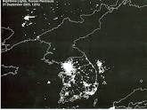
Does this picture help the reader visualize Shin Yong-Tae’s accounts of his personal experiences at the DMZ? Why or why not?

- From the reading, what do you think the word ‘conscripted’ mean?
Name:___________________________________________Date:____________Period:__________

Where No Man Goes, Wildlife Thrives

The border between South and North Korea is full of landmines and patrolled by millions of armed soldiers, but it's also home to thousands of flourishing species.
LAURA MOSS, September 18, 2014,

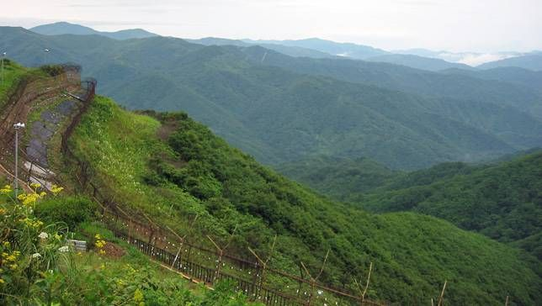
Where No Man Goes, Wildlife Thrives
But while the DMZ is one of the most dangerous places for humans, it's one of the safest places for wildlife. The armistice agreement created a buffer zone — more than a mile on either side of the military demarcation line — from which troops and military equipment are banned. The DMZ encompasses nearly 400 square miles of protected ecosystems, and the fact that mankind hasn't touched the area in more than 60 years, has allowed plant and animal species to flourish.
The DMZ and surrounding area incorporates a variety of landscapes, from mountains to wetlands, and nearly 3,000 species — many which are extinct or endangered elsewhere on the peninsula — thrive there amid the landmines.
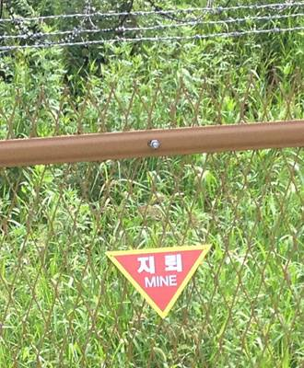
Otters, cranes, deer, Amur leopards, Asiatic black bears and thousands of other animals have been spotted roaming the region. There's even evidence of Siberian tigers, a species widely believed to be extinct on the peninsula.
In 1976, the South Korean government even designated one area along the DMZ a national monument after studies determined the region's importance to the survival of White-Naped Cranes. However, because no one ventures into the DMZ, much of its biodiversity is speculative. It's primarily based on studies conducted in the Civilian Control Zone, a 10-mile restricted stretch of land along the DMZ's southern boundary.

Rebranding the DMZ
While supporters of a reunified Korea have long promoted the preservation of the DMZ for parks and ecotourism, some areas near the border in South Korea already offer a glimpse of the region's ecological wonders. South Korea's Ministry developed part of the buffer along the military demarcation line into a "Peace and Life Zone" (PLZ). "The DMZ has been no man's land for decades, making its well-preserved natural surroundings a perfect site for eco-tourism," Park Mee-Ja, a director of the Environment Ministry explained. "Visitors can walk or drive along this 545km-long-course and on special occasions will be able to go right up to the border of the DMZ itself. After decades of seclusion, the PLZ, with its incredible biodiversity and profound history, is awaiting discovery." The DMZ is one of the most natural habitats left on Earth. Where most places are shrinking or seeing less biodiversity each year, the DMZ is thriving and becoming healthier. South Korea hopes future scientific discoveries and scientific trips will help show North Korea, and the world, the importance of the natural habitats.
South Korea hopes it can rebrand border tourism with the PLZ. "The DMZ has been a place of restriction and high security, but by turning this into an ecotourism zone, I think it will change how people see it. Rather than come to see the world's last divided country, in future we hope that more people will come here to experience the wildlife."

1. Why is the DMZ a flourishing natural habitat for plants and animals?

2. Why is the DMZ especially important for animals like the Siberian Tigers?

3. Why are scientists not allowed to study all of the DMZ to truly understand its importance?

4. Why did South Korea choose the name “Peace and Life Zone” for this eco-tourism zone?

5. If North and South Korea were to ever become united, or even just work with each other, what potential problems could this habitat deal with?

Mapping: Look up the following animals and color them in their boxes. Then, add them to your map by using a key/color symbol within the DMZ. Label North and South Korea.
Mountain Gorals
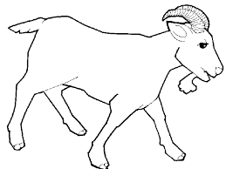

Amur Leopards
White Naped Crane
