DIRECTIONS: Use Google to identify the important details, achievements, and annotations about each historical figure from the Age of Imperialism listed below. Remember- avoid using Wikipedia!

Historical Figure | Annotations
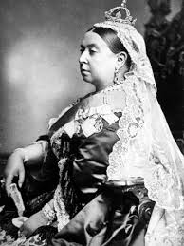  Queen Victoria  Empire: ____________________ | Time Period: ______________________________________  Achievements: ____________________________________________________________________________ ______________________________________________________________________________________________ ______________________________________________________________________________________________ ______________________________________________________________________________________________  Notes: ______________________________________________________________________________________  ______________________________________________________________________________________________  ______________________________________________________________________________________________
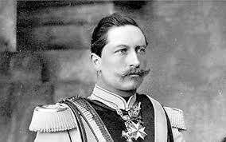  Kaiser Wilhelm II  Empire: ___________________ | Time Period: ______________________________________  Achievements: ____________________________________________________________________________ ______________________________________________________________________________________________ ______________________________________________________________________________________________ ______________________________________________________________________________________________  Notes: ______________________________________________________________________________________  ______________________________________________________________________________________________  ______________________________________________________________________________________________
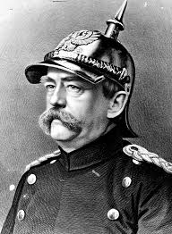  Otto von Bismarck  Empire: ________________ | Time Period: ______________________________________  Achievements: ____________________________________________________________________________ ______________________________________________________________________________________________ ______________________________________________________________________________________________ ______________________________________________________________________________________________  Notes: ______________________________________________________________________________________  ______________________________________________________________________________________________  ______________________________________________________________________________________________
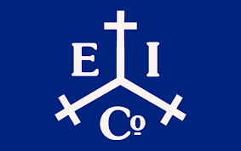  East India Company  Empire: ________________ | Time Period: ______________________________________  Achievements: ____________________________________________________________________________ ______________________________________________________________________________________________ ______________________________________________________________________________________________ ______________________________________________________________________________________________  Notes: ______________________________________________________________________________________  ______________________________________________________________________________________________  ______________________________________________________________________________________________
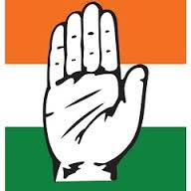  Indian National Congress  Empire: ________________ | Time Period: ______________________________________  Achievements: ____________________________________________________________________________ ______________________________________________________________________________________________ ______________________________________________________________________________________________ ______________________________________________________________________________________________  Notes: ______________________________________________________________________________________  ______________________________________________________________________________________________  ______________________________________________________________________________________________
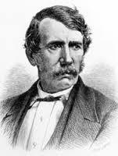  David Livingstone  Time Period: ________________ | Time Period: ______________________________________  Achievements: ____________________________________________________________________________ ______________________________________________________________________________________________ ______________________________________________________________________________________________ ______________________________________________________________________________________________  Notes: ______________________________________________________________________________________  ______________________________________________________________________________________________  ______________________________________________________________________________________________
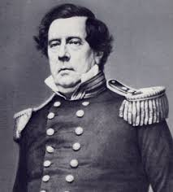  Commodore Matthew Perry  Empire: ________________ | Time Period: ______________________________________  Achievements: ____________________________________________________________________________ ______________________________________________________________________________________________ ______________________________________________________________________________________________ ______________________________________________________________________________________________  Notes: ______________________________________________________________________________________  ______________________________________________________________________________________________  ______________________________________________________________________________________________
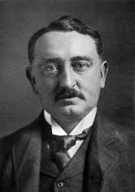  Cecil Rhodes  Empire: ________________ | Time Period: ______________________________________  Achievements: ____________________________________________________________________________ ______________________________________________________________________________________________ ______________________________________________________________________________________________ ______________________________________________________________________________________________  Notes: ______________________________________________________________________________________  ______________________________________________________________________________________________  ______________________________________________________________________________________________
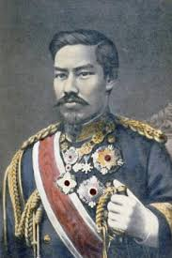  Emperor Meiji  Empire: ________________ | Time Period: ______________________________________  Achievements: ____________________________________________________________________________ ______________________________________________________________________________________________ ______________________________________________________________________________________________ ______________________________________________________________________________________________  Notes: ______________________________________________________________________________________  ______________________________________________________________________________________________  ______________________________________________________________________________________________
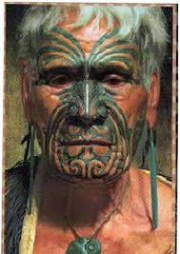  Maori  Empire: ________________ | Time Period: ______________________________________  Achievements: ____________________________________________________________________________ ______________________________________________________________________________________________ ______________________________________________________________________________________________ ______________________________________________________________________________________________  Notes: ______________________________________________________________________________________  ______________________________________________________________________________________________  ______________________________________________________________________________________________
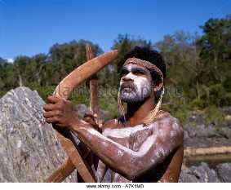  Aborigine  Empire: ________________ | Time Period: ______________________________________  Achievements: ____________________________________________________________________________ ______________________________________________________________________________________________ ______________________________________________________________________________________________ ______________________________________________________________________________________________  Notes: ______________________________________________________________________________________  ______________________________________________________________________________________________  ______________________________________________________________________________________________
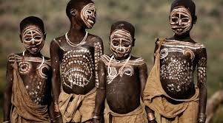  Zulu  Empire: ________________ | Time Period: ______________________________________  Achievements: ____________________________________________________________________________ ______________________________________________________________________________________________ ______________________________________________________________________________________________ ______________________________________________________________________________________________  Notes: ______________________________________________________________________________________  ______________________________________________________________________________________________  ______________________________________________________________________________________________
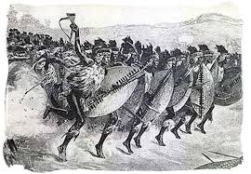  Boer  Empire: ________________ | Time Period: ______________________________________  Achievements: ____________________________________________________________________________ ______________________________________________________________________________________________ ______________________________________________________________________________________________ ______________________________________________________________________________________________  Notes: ______________________________________________________________________________________  ______________________________________________________________________________________________  ______________________________________________________________________________________________
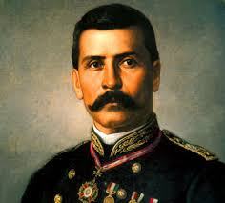  Porfirio Diaz  Country: ________________ | Time Period: ______________________________________  Achievements: ____________________________________________________________________________ ______________________________________________________________________________________________ ______________________________________________________________________________________________ ______________________________________________________________________________________________  Notes: ______________________________________________________________________________________  ______________________________________________________________________________________________  ______________________________________________________________________________________________
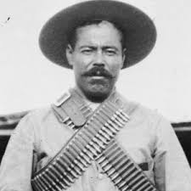  Pancho Villa  Country: ________________ | Time Period: ______________________________________  Achievements: ____________________________________________________________________________ ______________________________________________________________________________________________ ______________________________________________________________________________________________ ______________________________________________________________________________________________  Notes: ______________________________________________________________________________________  ______________________________________________________________________________________________  ______________________________________________________________________________________________
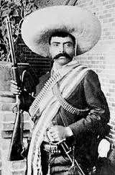  Emiliano Zapata  Country: ________________ | Time Period: ______________________________________  Achievements: ____________________________________________________________________________ ______________________________________________________________________________________________ ______________________________________________________________________________________________ ______________________________________________________________________________________________  Notes: ______________________________________________________________________________________  ______________________________________________________________________________________________  ______________________________________________________________________________________________
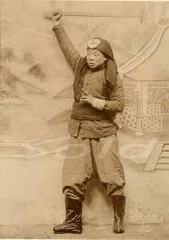  Yihetuan  Empire: ___________________ | Time Period: ______________________________________  Achievements: ____________________________________________________________________________ ______________________________________________________________________________________________ ______________________________________________________________________________________________ ______________________________________________________________________________________________  Notes: ______________________________________________________________________________________  ______________________________________________________________________________________________  ______________________________________________________________________________________________

