DIRECTIONS: Use the PowerPoint “NOTES: History’s A-HA Moment!” on heymissaworld.weebly.com to identify the important details, achievements, and annotations about each historical figure from the Enlightenment listed below.

Historical Figure | Annotations
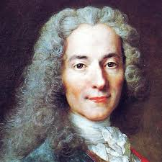Voltaire  Time Period: ________________ | Famous Works: ______________________________________  Philosophy: ____________________________________________________________________________ ______________________________________________________________________________________________ ______________________________________________________________________________________________ ______________________________________________________________________________________________  Influenced: ________________________________________________________________________________  ______________________________________________________________________________________________  ______________________________________________________________________________________________
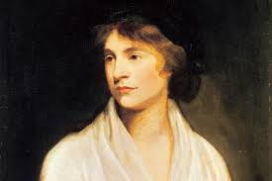  Mary Wollstonecraft  Time Period: ________________ | Famous Works: ______________________________________  Philosophy: ____________________________________________________________________________ ______________________________________________________________________________________________ ______________________________________________________________________________________________ ______________________________________________________________________________________________  Influenced: ________________________________________________________________________________  ______________________________________________________________________________________________  ______________________________________________________________________________________________
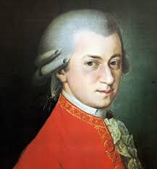  Mozart  Time Period: ________________ | Famous Works: ______________________________________  Philosophy: ____________________________________________________________________________ ______________________________________________________________________________________________ ______________________________________________________________________________________________ ______________________________________________________________________________________________  Influenced: ________________________________________________________________________________  ______________________________________________________________________________________________  ______________________________________________________________________________________________
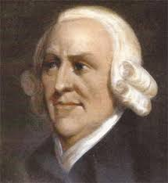  Adam Smith  Time Period: ________________ | Famous Works: ______________________________________  Philosophy: ____________________________________________________________________________ ______________________________________________________________________________________________ ______________________________________________________________________________________________ ______________________________________________________________________________________________  Influenced: ________________________________________________________________________________  ______________________________________________________________________________________________  ______________________________________________________________________________________________
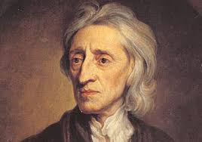  John Locke  Time Period: ________________ | Famous Works: ______________________________________  Philosophy: ____________________________________________________________________________ ______________________________________________________________________________________________ ______________________________________________________________________________________________ ______________________________________________________________________________________________  Influenced: ________________________________________________________________________________  ______________________________________________________________________________________________  ______________________________________________________________________________________________
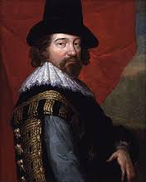  Francis Bacon  Time Period: ________________ | Famous Works: ______________________________________  Philosophy: ____________________________________________________________________________ ______________________________________________________________________________________________ ______________________________________________________________________________________________ ______________________________________________________________________________________________  Influenced: ________________________________________________________________________________  ______________________________________________________________________________________________  ______________________________________________________________________________________________
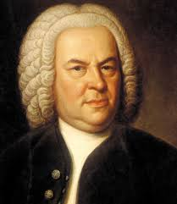  Johann Sebastian Bach  Time Period: ________________ | Famous Works: ______________________________________  Philosophy: ____________________________________________________________________________ ______________________________________________________________________________________________ ______________________________________________________________________________________________ ______________________________________________________________________________________________  Influenced: ________________________________________________________________________________  ______________________________________________________________________________________________  ______________________________________________________________________________________________
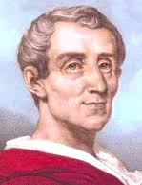  Montesquieu  Time Period: ________________ | Famous Works: ______________________________________  Philosophy: ____________________________________________________________________________ ______________________________________________________________________________________________ ______________________________________________________________________________________________ ______________________________________________________________________________________________  Influenced: ________________________________________________________________________________  ______________________________________________________________________________________________  ______________________________________________________________________________________________
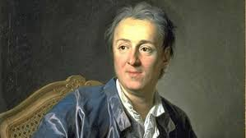  Denis Diderot  Time Period: ________________ | Famous Works: ______________________________________  Philosophy: ____________________________________________________________________________ ______________________________________________________________________________________________ ______________________________________________________________________________________________ ______________________________________________________________________________________________  Influenced: ________________________________________________________________________________  ______________________________________________________________________________________________  ______________________________________________________________________________________________
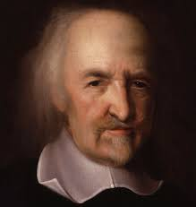  Thomas Hobbes  Time Period: ________________ | Famous Works: ______________________________________  Philosophy: ____________________________________________________________________________ ______________________________________________________________________________________________ ______________________________________________________________________________________________ ______________________________________________________________________________________________  Influenced: ________________________________________________________________________________  ______________________________________________________________________________________________  ______________________________________________________________________________________________
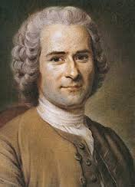  Jean Jacques Rousseau  Time Period: ________________ | Famous Works: ______________________________________  Philosophy: ____________________________________________________________________________ ______________________________________________________________________________________________ ______________________________________________________________________________________________ ______________________________________________________________________________________________  Influenced: ________________________________________________________________________________  ______________________________________________________________________________________________  ______________________________________________________________________________________________
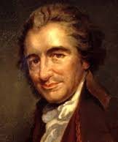  Thomas Paine  Time Period: ________________ | Famous Works: ______________________________________  Philosophy: ____________________________________________________________________________ ______________________________________________________________________________________________ ______________________________________________________________________________________________ ______________________________________________________________________________________________  Influenced: ________________________________________________________________________________  ______________________________________________________________________________________________  ______________________________________________________________________________________________
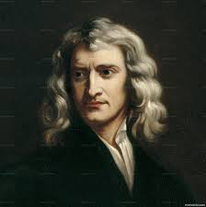  Isaac Newton  Time Period: ________________ | Famous Works: ______________________________________  Philosophy: ____________________________________________________________________________ ______________________________________________________________________________________________ ______________________________________________________________________________________________ ______________________________________________________________________________________________  Influenced: ________________________________________________________________________________  ______________________________________________________________________________________________  ______________________________________________________________________________________________
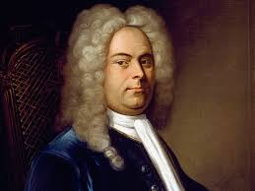  George Frederick Handel  Time Period: ________________ | Famous Works: ______________________________________  Philosophy: ____________________________________________________________________________ ______________________________________________________________________________________________ ______________________________________________________________________________________________ ______________________________________________________________________________________________  Influenced: ________________________________________________________________________________  ______________________________________________________________________________________________  ______________________________________________________________________________________________
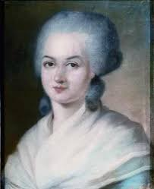  Olympe de Gouges  Time Period: ________________ | Famous Works: ______________________________________  Philosophy: ____________________________________________________________________________ ______________________________________________________________________________________________ ______________________________________________________________________________________________ ______________________________________________________________________________________________  Influenced: ________________________________________________________________________________  ______________________________________________________________________________________________  ______________________________________________________________________________________________

