DIRECTIONS: Use Google to identify the important details, achievements, and annotations about each historical figure from World War I listed below. Remember- avoid using Wikipedia!

Historical Figure | Annotations
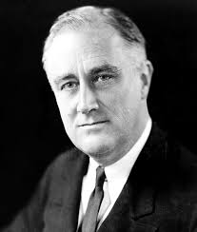  Franklin D. Roosevelt  Nationality: __________________ | Time Period: ______________________________________  Achievements: ____________________________________________________________________________ ______________________________________________________________________________________________ ______________________________________________________________________________________________ ______________________________________________________________________________________________  Notes: ______________________________________________________________________________________  ______________________________________________________________________________________________  ______________________________________________________________________________________________
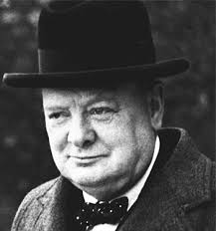  Winston Churchill  Nationality: _________________ | Time Period: ______________________________________  Achievements: ____________________________________________________________________________ ______________________________________________________________________________________________ ______________________________________________________________________________________________ ______________________________________________________________________________________________  Notes: ______________________________________________________________________________________  ______________________________________________________________________________________________  ______________________________________________________________________________________________
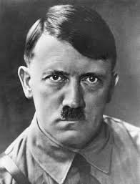  Adolf Hitler  Nationality: ________________ | Time Period: ______________________________________  Achievements: ____________________________________________________________________________ ______________________________________________________________________________________________ ______________________________________________________________________________________________ ______________________________________________________________________________________________  Notes: ______________________________________________________________________________________  ______________________________________________________________________________________________  ______________________________________________________________________________________________
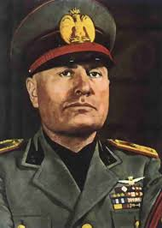  Benito Mussolini  Nationality: ________________ | Time Period: ______________________________________  Achievements: ____________________________________________________________________________ ______________________________________________________________________________________________ ______________________________________________________________________________________________ ______________________________________________________________________________________________  Notes: ______________________________________________________________________________________  ______________________________________________________________________________________________  ______________________________________________________________________________________________
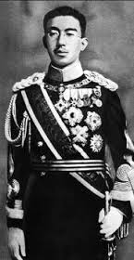  Hirohito  Nationality: ________________ | Time Period: ______________________________________  Achievements: ____________________________________________________________________________ ______________________________________________________________________________________________ ______________________________________________________________________________________________ ______________________________________________________________________________________________  Notes: ______________________________________________________________________________________  ______________________________________________________________________________________________  ______________________________________________________________________________________________
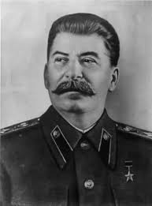  Josef Stalin  Nationality: ________________ | Time Period: ______________________________________  Achievements: ____________________________________________________________________________ ______________________________________________________________________________________________ ______________________________________________________________________________________________ ______________________________________________________________________________________________  Notes: ______________________________________________________________________________________  ______________________________________________________________________________________________  ______________________________________________________________________________________________
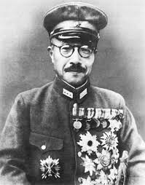  Hideki Tojo  Nationality: ________________ | Time Period: ______________________________________  Achievements: ____________________________________________________________________________ ______________________________________________________________________________________________ ______________________________________________________________________________________________ ______________________________________________________________________________________________  Notes: ______________________________________________________________________________________  ______________________________________________________________________________________________  ______________________________________________________________________________________________
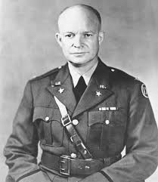  Dwight D. Eisenhower  Nationality: ________________ | Time Period: ______________________________________  Achievements: ____________________________________________________________________________ ______________________________________________________________________________________________ ______________________________________________________________________________________________ ______________________________________________________________________________________________  Notes: ______________________________________________________________________________________  ______________________________________________________________________________________________  ______________________________________________________________________________________________
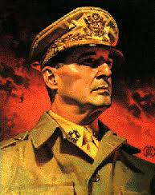  Douglas MacArthur  Nationality: ________________ | Time Period: ______________________________________  Achievements: ____________________________________________________________________________ ______________________________________________________________________________________________ ______________________________________________________________________________________________ ______________________________________________________________________________________________  Notes: ______________________________________________________________________________________  ______________________________________________________________________________________________  ______________________________________________________________________________________________
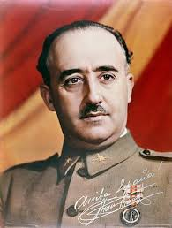  Francisco Franco  Nationality: ________________ | Time Period: ______________________________________  Achievements: ____________________________________________________________________________ ______________________________________________________________________________________________ ______________________________________________________________________________________________ ______________________________________________________________________________________________  Notes: ______________________________________________________________________________________  ______________________________________________________________________________________________  ______________________________________________________________________________________________
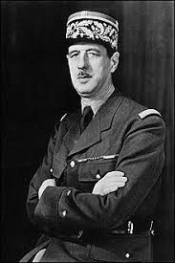  Charles de Gaulle  Nationality: ________________ | Time Period: ______________________________________  Achievements: ____________________________________________________________________________ ______________________________________________________________________________________________ ______________________________________________________________________________________________ ______________________________________________________________________________________________  Notes: ______________________________________________________________________________________  ______________________________________________________________________________________________  ______________________________________________________________________________________________
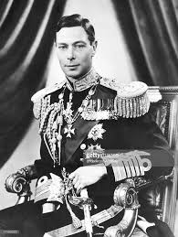  King George VI  Nationality: ________________ | Time Period: ______________________________________  Achievements: ____________________________________________________________________________ ______________________________________________________________________________________________ ______________________________________________________________________________________________ ______________________________________________________________________________________________  Notes: ______________________________________________________________________________________  ______________________________________________________________________________________________  ______________________________________________________________________________________________
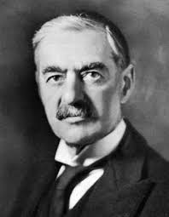  Neville Chamberlain  Nationality: ________________ | Time Period: ______________________________________  Achievements: ____________________________________________________________________________ ______________________________________________________________________________________________ ______________________________________________________________________________________________ ______________________________________________________________________________________________  Notes: ______________________________________________________________________________________  ______________________________________________________________________________________________  ______________________________________________________________________________________________
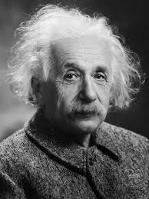  Albert Einstein  Nationality: ________________ | Time Period: ______________________________________  Achievements: ____________________________________________________________________________ ______________________________________________________________________________________________ ______________________________________________________________________________________________ ______________________________________________________________________________________________  Notes: ______________________________________________________________________________________  ______________________________________________________________________________________________  ______________________________________________________________________________________________
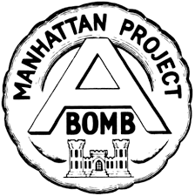  Manhattan Project  Nationality: ________________ | Time Period: ______________________________________  Achievements: ____________________________________________________________________________ ______________________________________________________________________________________________ ______________________________________________________________________________________________ ______________________________________________________________________________________________  Notes: ______________________________________________________________________________________  ______________________________________________________________________________________________  ______________________________________________________________________________________________
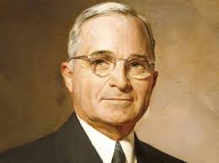  Harry S. Truman  Nationality: ________________ | Time Period: ______________________________________  Achievements: ____________________________________________________________________________ ______________________________________________________________________________________________ ______________________________________________________________________________________________ ______________________________________________________________________________________________  Notes: ______________________________________________________________________________________  ______________________________________________________________________________________________  ______________________________________________________________________________________________
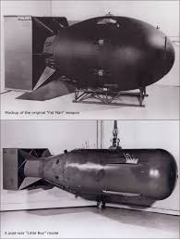  “Fat Man” & “Little Boy” | Time Period: ______________________________________  Achievements: ____________________________________________________________________________ ______________________________________________________________________________________________ ______________________________________________________________________________________________ ______________________________________________________________________________________________  Notes: ______________________________________________________________________________________  ______________________________________________________________________________________________  ______________________________________________________________________________________________

