Directions: The first thing you need to do is use a device and Google your term plus the word ‘definition’. Then, you will need to circle the sentence that you think is using the word correctly! Enjoy your learning and this is due at the END OF THE PERIOD!
Vocabulary Term: | Definition: | Sentence Use:
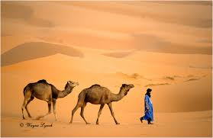  Sahara |  | - Groups of camels called Saharas are used to travel across deserts for long periods of time.  - The Sahara is a physical feature 16 times the size of France that separates North Africa from South Africa.
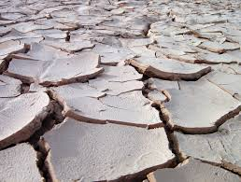Desertification |  | - The Sahel is an area below the Sahara that experiences rapid desertification, with bodies of water decreasing daily.  - Desertification is a crime that occurs when soldiers leave their assignments without permission.
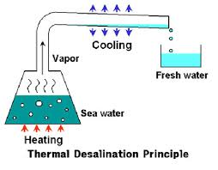  Desalination |  | - Many countries in the Middle East are focusing on making seawater drinkable through desalination.  - Many countries in the Middle East use desalination to find new oil deposits.
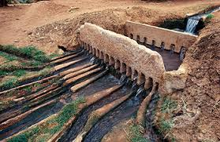  Irrigation |  | - Farmers in Egypt use irrigation to carry water from the Nile River to their crops.  - Irrigation is the cause of seasonal floods in the Sahara desert.
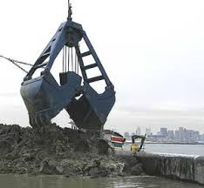  Dredging |  | - Countries on the Arabian Peninsula use dredging to create more living space due to overpopulation.  - The man-made islands of Dubai were created by dredging sand from the floor of the Persian Gulf.
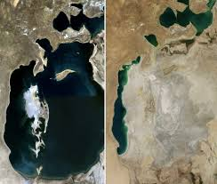  Aral Sea |  | - The disappearing Aral Sea has impacted population distribution in the Middle East by causing people to move closer to other water sources.  - The Aral Sea is home to an abundance of marine life and the world’s largest barrier reef.
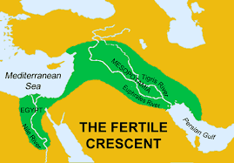Fertile Crescent |  | - The Sun’s direct rays has made the Fertile Crescent desirable for people who wish to earn a living designing sunglasses.  - Civilizations developed along the Fertile Crescent because it has arable soil, unusual for the dry conditions of the Middle East.
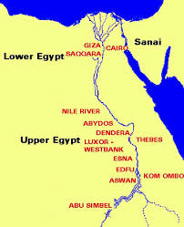  Nile River Valley |  | - The Nile River Valley has provided fertile soil and agricultural opportunities in Egypt.  - The Nile River Valley runs through a jungle in South America.

