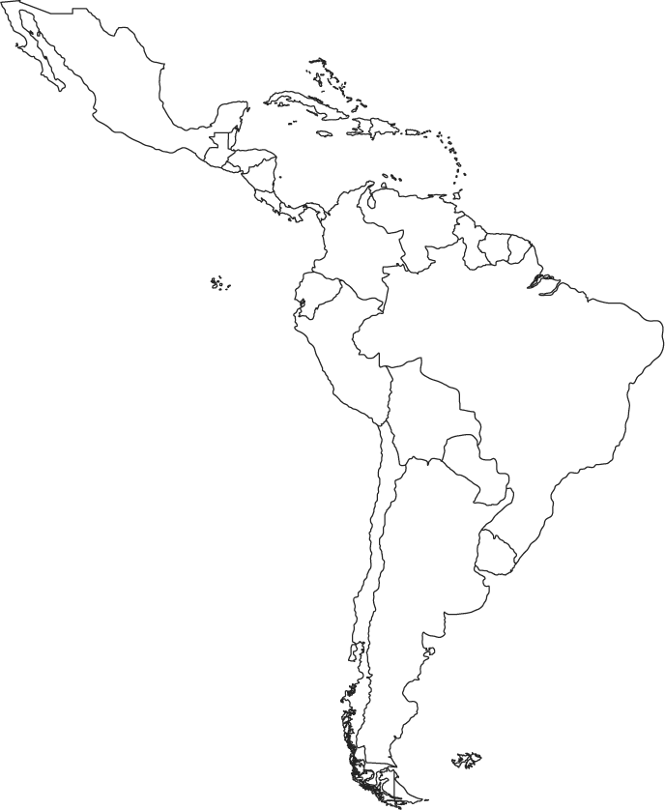

*Draw a battle scene from the Spanish-American War*

**Spanish American War**

**Exports**

**Economic Growth**

**Panama Canal**

**Monroe Doctrine**

**Imperialism in Latin America**

*Sugarcane is…*