The Age of Imperialism: Analyzing Political Cartoons
DIRECTIONS: Explore the objectives and opinions of historical topics that are presented in the political cartoons below. Use the questions to help you determine what the artist was trying to express. Use your notes for evidence to back up your answers.
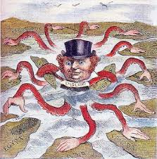
I. British Imperialism
T | Time
A | Action
C | Caption
O | Objects
S | Summary

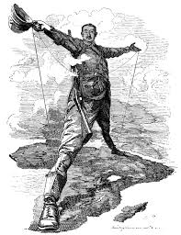
II. The Rhodes Colossus
T | Time
A | Action
C | Caption
O | Objects
S | Summary

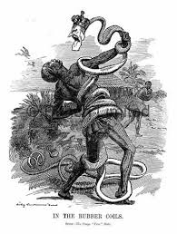
III. In the Rubber Coils of the Congo Free State
T | Time
A | Action
C | Caption
O | Objects
S | Summary

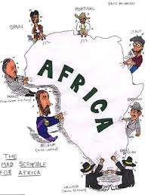
IV. The Mad Scramble for Africa
T | Time
A | Action
C | Caption
O | Objects
S | Summary

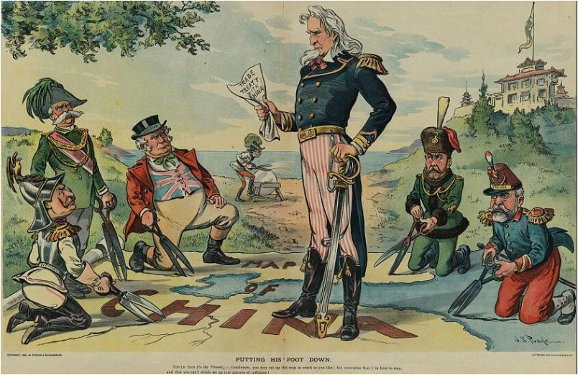
V. Putting His Foot Down
T | Time
A | Action
C | Caption
O | Objects
S | Summary

VI. Welcome to the Philippines
T | Time
A | Action
C | Caption
O | Objects
S | Summary
