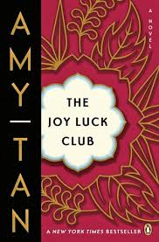

Why was Waverly confused about where Lindo came from?

*What special thing can Lindo do that changes Waverly’s opinions or feelings about someone?*

*Why does Waverly feel that Lindo is the queen and she is the pawn?*

**How does dinner with Rich and Waverly’s family go?**

**What are some of the “mistakes” Rich made at dinner?**

Why did Waverly first stop playing chess as a child?

**The Joy Luck Club: Chapter 10**

***What did Waverly want to tell her mother at lunch?***

*How did Lindo react when Waverly eloped with her first husband?*

**List the MAIN Events of Chapter 10:**