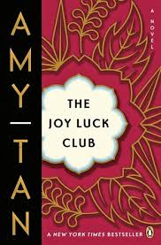

What was Rose like as a child?

*What does the phrase “without wood” mean?*

*Why does An-Mei, Rose’s mother, use that phrase to describe her daughter?*

**How does Rose describe her feelings about her divorce to Waverly?**

**… to Lena?**

**---to her psychiatrist?**

Why is Rose puzzled by the check Ted sent her?

**The Joy Luck Club: Chapter 11**

***Why is Rose proud of the weeds in the garden?***

*When Rose says that Ted is* ***hulihudu****, what is she saying about him?*

**List the MAIN Events of Chapter 11:**