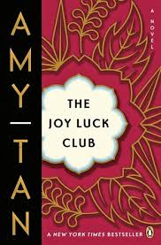

What gift of “life importance” did Jing-Mei receive from her mother?

*What happened to the crabs Suyuan selected for the New Year?*

*Why does Suyuan refuse to take the crab?*

**How does Waverly get under Jing-Mei’s skin?**

**How does Jing-Mei respond?**

**What does Waverly ultimately say about Jing-Mei?**

Why didn’t Suyuan eat the crab she selected at dinner?

**The Joy Luck Club: Chapter 12**

***The chapter ends in the present. Why was the crab Suyuan selected at dinner an omen?***

*What virtue does Suyuan say Jing-Mei has?*

**List the MAIN Events of Chapter 12:**