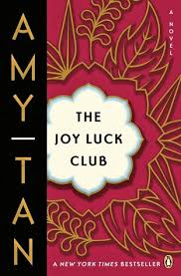

What was the significance of the day of An-Mei’s mother’s death?

*Describe Second Wife’s personality.*

*What is wrong with the “gift” she gave An-Mei?*

**What is Wu Tsing’s first wife like?**

**Why did Wu Tsing need a Fourth Wife if his Third Wife had children?**

**Who does Wu Tsing bring back with him?**

What was An-Mei’s mother’s great sorrow?

**The Joy Luck Club: Chapter 13**

***Why does An-Mei say it is useless to cry?***

*Where does An-Mei go after Popo dies?*

**List the MAIN Events of Chapter 13:**