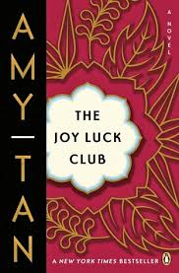

What sign convinced Ying-Ying that she would marry the guest in her family’s home?

*What is the difference between what Lena sees in her mother and how Ying-Ying really is?*

**What was Ying-Ying’s first husband like?**

**Why did he leave her?**

**What did Ying-Ying do after he left?**

How does Ying-Ying’s privileged youth differ from her life after her first marriage?

**The Joy Luck Club: Chapter 14**

***What does Ying-Ying want to do for Lena?***

*What did Ying-Ying give up when she married Clifford?*

**List the MAIN Events of Chapter 14:**