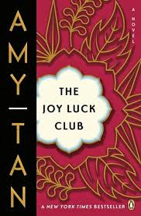

*Why does Waverly want to be especially Chinese?*

Why does Lindo’s daughter Waverly want to go to China?

**Who first told Lindo about America?**

**What kind of job did Lindo get in the cookie factory?**

**What was the fortune inside the cookie Lindo gave Tin?**

*Why do you think Lindo believes her children could not have American circumstances and Chinese character?*

**The Joy Luck Club: Chapter 15**

***Why does Waverly like the fact that she and Lindo have crooked noses?***

*At the end, what is Lindo wondering about?*

**List the MAIN Events of Chapter 15:**