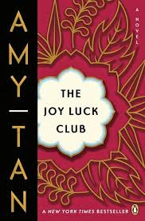

*Where is Jing-Mei meeting her two half-sisters?*

Why does Jing-Mei feel different as her train leaves Hong Kong?

**Why did Suyuan actually leave the babies?**

**Who found the babies?**

*How did the half-sisters learn their mother was dead?*

**The Joy Luck Club: Chapter 16**

***What are the two different Chinese meanings of Suyuan, Jing-Mei’s mother’s name?***

*What is the meaning of Jing-Mei?*

**List the MAIN Events of Chapter 16:**