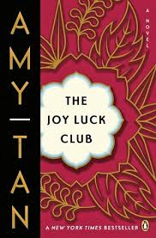

The novel opens with a parable that introduces the theme of the chapters that follow it. What is the main idea of the first parable, *“Feathers from a Thousand Li Away”?*

Why is Jing-Mei taking part in the Joy Luck Club?

**List the MAIN Events of Chapter 1:**

How many Joy Luck Clubs have there been?

What does *Joy Luck* mean?

**The Joy Luck Club: Chapter 1**

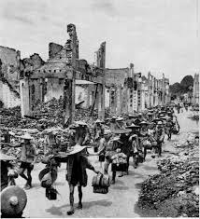

Why did Suyuan have to leave Kweilin?

Why do you think these things happened?

What global event is taking place while the Japanese are invading Kweilin?

**What information did Jing-Mei finally learn from Suyuan’s story about leaving Kweilin?**

**What does Jing-Mei tell her “aunties” about her mother that surprises them?**

**How does the parable from the beginning of the chapter reflect in Jing-Mei’s memories of her mother?**