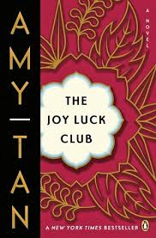

**List the MAIN Events of Chapter 2:**

**In An-Mei’s family, what did it mean to become a ghost?**

**What does it mean to be a “ghost” today?**

**What did An-Mei’s mother do to become a ghost to her family?**

In the chapter, what is the definition of ***shou***?

**The Joy Luck Club: Chapter 2**

What memory does An-Mei recall from when she was four years old?

What did her grandmother tell her to make her feel better?

**How does An-Mei find out what happened to her mother?**

**What does her family say about her mother?**

**How does this information change the way An-Mei thinks of her mother?**

**What selfless act does An-Mei’s mother do that changes the way An-Mei sees her?**