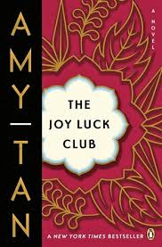

**How did Lindo become engaged to her first husband?**

**How did Lindo become a member of the Huang household?**

**How does that differ from relationships in the U.S. today?**

**What gift did Lindo’s mother give her as the family moved away?**

**List the MAIN Events of Chapter 3:**

**The Joy Luck Club: Chapter 3**

**What was the significance of the story of Festival of Pure Brightness?**

**Why was Lindo unafraid as she was led down the path on her wedding day?**

*What was the red candle’s significance and what was supposed to happen to it?*

What did Lindo use as “evidence” that her marriage to Tyan-yu was rotting?

How did Lindo escape her marriage to Tyan-yu?