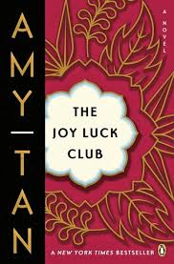

**What does Ying-Ying say her earliest memory (recollection) is?**

*Why did the Amah tell Ying-Ying to keep her wishes secret?*

***What is the ultimate fate of the Moon Lady?***

***What does the Moon Lady represent for Ying-Ying?***

***What wish does Ying-Ying ask of the Moon Lady?***

**How did Ying-Ying end up in the water?**

**The Joy Luck Club: Chapter 4**

How does Ying-Ying’s story reflect her life and that of her daugher?

**List the MAIN Events of Chapter 4:**