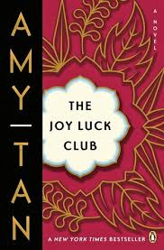p

***How does the parable of the girl and her bicycle reflect on Waverly’s relationship with her mother, Lindo?***

**What was the art of “invisible strength” that Waverly’s mother taught her?**

**How did Waverly’s mother demonstrate this strength?**

**List the MAIN Events of Chapter 5:**

**The Joy Luck Club: Chapter 5**

*Why did Waverly run away***?**

*How did Waverly learn to play expert chess?*

*What does Waverly’s mother compare playing chess to?*

*How did Waverly’s mother treat her when she came home?*

At the end of the story, who is Waverly’s imaginary chess opponent? Why do you think this is?