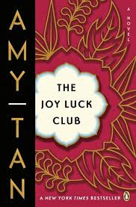

**List the MAIN Events of Chapter 6:**

***How have Ying-Ying’s stories and warnings shaped Lena’s character?***

***Why does Lena want to know about all of the worst things that could possibly happen to her?***

**Ying-Ying’s immigration papers are full of errors- what are some of the “mistakes” made on her documents?**

*Lena gives many examples that describe Ying-Ying’s mental and emotional state. Provide some examples below.*

*Compare Lena’s description of her mother with Ying-Ying’s character in Ch. 4.*

**The Joy Luck Club: Chapter 6**

What hope did Lena have after watching the girl next door and her mother, who have been fighting throughout the chapter?

*What kind of lies does Lena tell? Why does she tell them?*

*What is unusual about Lena’s parents’ relationship***?**