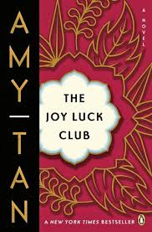

*What does Ted’s mother say to Rose?*

**What item did Rose’s mother An-Mei carry with her to church?**

**Where is that item now?**

**List the MAIN Events of Chapter 7:**

How do Ted and Rose evolve in their marriage?

***Does An-Mei ever lose hope for Bing or for Rose’s marriage?***

***When Rose reads her mother’s Bible, what does she find written in it?***

***Why did An-Mei write it in pencil?***

**The Joy Luck Club: Chapter 7**

*How is “faith” presented in the novel?*

*What is “nengkan”?*

*How are An-Mei’s actions at the beach an example of her “nengkan”?*

Who is Bing? What happens to him?