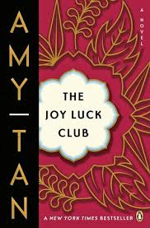

What made Jing-Mei’s mother believe she could be a prodigy?

*What activities does Suyuan pursue to mold Jing-Mei into a Chinese prodigy?*

*What is Jing-Mei’s attitude towards these activities?*

*How did Jing-Mei first envision herself as a prodigy?*

**What is unusual about Jing-Mei’s piano teacher and how does this affect her playing?**

**What piece does Jing-Mei select for the recital?**

**Who is the only person who was impressed by Jing-Mei’s performance?**

What activity does Suyuan finally believe will turn Jing-Mei into a prodigy?

**The Joy Luck Club: Chapter 8**

*What does Jing-Mei notice about “Pleading Child” and “Perfectly Contented”, the songs she plays at the piano?*

***What does Jing-Mei say to her mother during their fight at the piano?***

**List the MAIN Events of Chapter 8:**