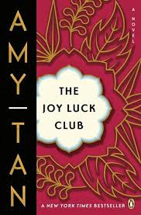

Why does the marble end table collapse?

*How would you describe Lena and Harold’s relationship?*

*What does Harold realize about Lena after Ying-Ying’s outburst?*

*How does Harold treat Lena’s emotions?*

**What are the three things that Lena’s mother predicted that came true?**

**1.**

**2.**

**3.**

Why does Lena feel nervous about her mother’s visit with her and Harold?

**The Joy Luck Club: Chapter 9**

*What does Lena’s mother, Ying-Ying, see?*

***What do you think the phrase “the lips are gone, the teeth will be cold” means?***

**List the MAIN Events of Chapter 9:**