Vocabulary Term: | Definition: | Sentence Use:
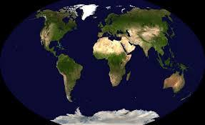  Map Projection |  | - Many map projections are named after constellations in the Milky Way galaxy.  - Many map projections are named for the cartographer’s, or map makers, that discovered their use.
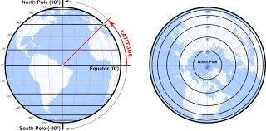  Latitude |  | - Latitudes are often called parallels because they run horizontally across the Earth and never intersect.  - The Prime Meridian is a latitude line that sits at 64˚S.
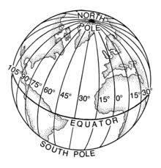  Longitude |  | - The Equator is a line of longitude that sits 25˚ N.  - Lines of longitude intersect at the North and South Poles.
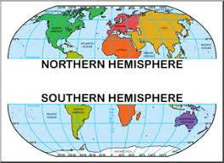  Hemisphere |  | - A hemisphere is a set of parallel lines that divides the Earth between East and West.  - The half of the Earth that is west of the Prime Meridian is known as the Western Hemisphere.
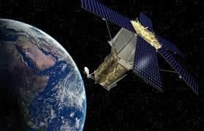  Remote Sensing |  | - Remote Sensing allows televisions to pick up signals from replacement remote controls.  - Geographers can use remote sensing to track the changes in a city’s growth over time
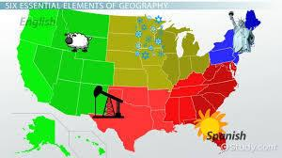  Spatial Perspective |  | - Geographers use spatial perspective to understand the effect of outer space on Earth’s atmosphere.  - Spatial perspective includes the study of a region’s climate, topography and physical surroundings.
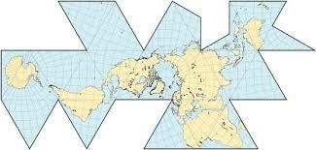Map Distortion |  | - A Mercator projection uses map distortion to make areas further away from the Equator seem larger than they are.  - Map distortion occurs when a geographer doesn’t ask the teacher to double check his work.
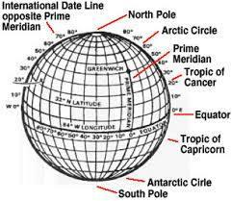  Grid System |  | - The grid system of latitude and longitude lines helps geographers find the absolute location of a place.  - The grid system allows geographers to show all of Earth’s land equally while shrinking all of Earth’s water.

