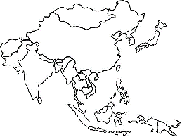

**Mapping Lab: Asia**

*Using your Map Guidelines in your ISN, please locate, NEATLY label, and lightly shade (with COLORED PENCILS) the following items. Read and follow ALL instructions carefully!*

1. Create:
   1. Map Title, Compass Rose, Scale
   2. Legend
2. Label the Following Countries:
   1. India (South)
   2. Nepal (South)
   3. Pakistan (South)
   4. Japan (East)
   5. N. Korea/S. Korea (East)
   6. Mongolia (East)
   7. China (East)
   8. Thailand (SE)
   9. Vietnam (SE)
   10. Cambodia (SE)
   11. Indonesia (SE)
3. Label, Draw & LIGHTLY SHADE in the following Bodies of Water:
   1. Pacific Ocean
   2. Huang He (Yellow) River
   3. Chang Jiang (Yangtze) River
   4. Indian Ocean
   5. Bay of Bengal
   6. South China Sea
   7. Ganges River
   8. Indus River
4. Label, Draw & LIGHTLY SHADE in the following physical features:
   1. Gobi Desert
   2. Himalayas Mountains
   3. Mt. Everest
5. Label and draw 5 economic activities per section of the map.
   1. East Asia
   2. South Asia
6. LIGHTLY SHADE in the rest of the map according to a Population Density Map.