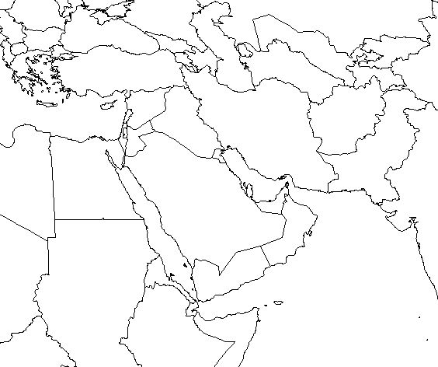

Mapping Lab: Middle East

Mapping Lab: Middle East

*Use both the following instructions AND the Map Instructions (for coloring) on page 8 in your ISN to complete the map.*

* Locate & Label all countries.
* Label all capitol cities.
* Draw, **Lightly Shade** & Label the following physical features:
  + Zagros Mountains
  + Plateau of Iran
  + Arabian Peninsula
* Draw, Color & Label the following Bodies of Water:
  + Nile River
  + Tigris River
  + Euphrates River
  + Persian Gulf
  + Gulf of Oman
  + Arabian Sea
  + Red Sea
  + Mediterranean Sea
  + Indus River

Tip: Use maps for the Middle East, Asia, and Africa to locate items on map.