Name____________________________________________________________________________Date_________________________Period_________________________

Marvels of the Renaissance

Directions: Match the pictures of Renaissance accomplishments to their country’s location by drawing lines from the image to the dots on the map. Then fill in the chart on the next page with the missing information. Use our class website, www.heymissaworld.weebly.com, and the links available under “Marvels of the Renaissance”.
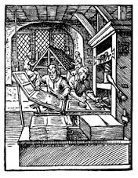
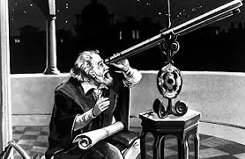
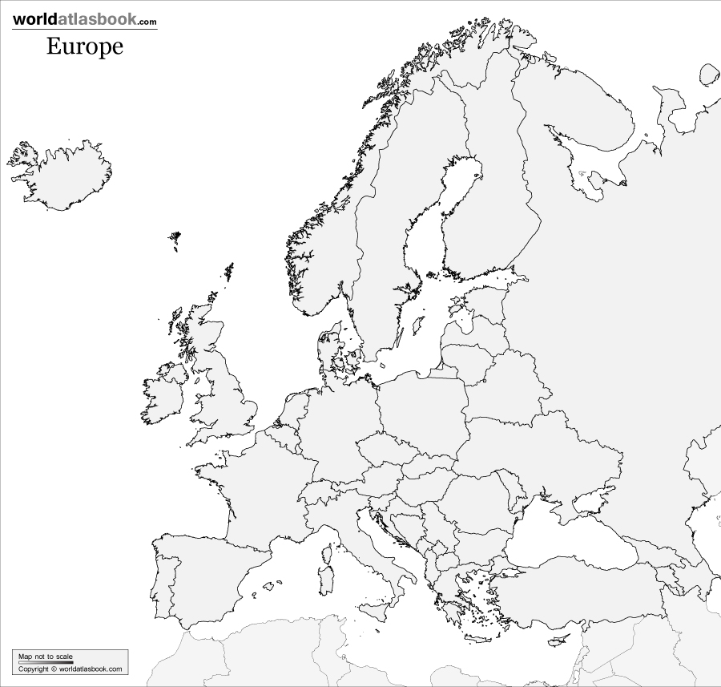

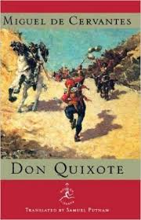
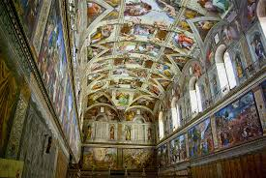

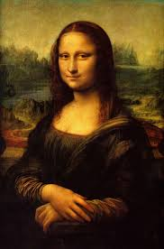
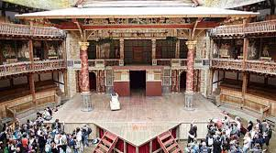

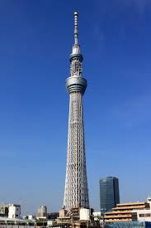

Marvel | Where was it made? | How did it work? | What is it used for? | Who made it?
Printing Press |  | Removable letters are pressed against parchment to print large readings at once.
Telescope

Don Quixote |  |  |  | Miguel de Cervantes
Last Judgement | Sistine Chapel,  Vatican City (Rome)
Mona Lisa

Globe Theater |  |  | The original Globe was used for producing and staging _______________ plays.

