

Jot Down the Main Events of **Chapter 1:**

***Why does Artie refer to Mala as a “survivor” like his parents?***

***What did they survive?***

How are characters presented in MAUS?

**MAUS: The Sheik**

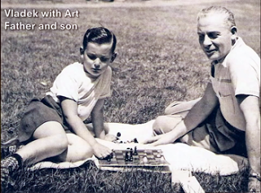

Read the above quote and compare it to Vladek’s personality in the chapter. In what ways have the experiences of the Holocaust affected survivors?

No dictionary in the world could supply the words for what I saw next. My mother begged me to be a witness, however; all these years I’ve been talking and telling, and I’m not sure if anybody listens or understands me. I myself am not sure if I understand.

The following night my brother and I were miraculously escaped the final deportation, only to be shipped off to the camps separately soon afterward. I never saw my mother again, nor was I ever able to find a picture of her. Whenever I want to remember her I close my eyes and think of that Sunday in August of 1942, when I saw her sitting in our ghetto garden, crying behind the lilac tree.

-Bernard Gotfryd

Holocaust Survivor

“The Last Morning” from “Anton: The Dove Fancier”

On page 14, we see a close-up of Vladek as he pedals his bicycle.

What information about Vladek are we given in the fifth panel?