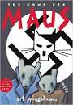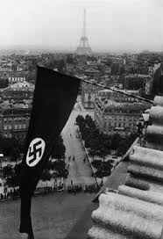

***What catches the Spiegelman’s and the other passengers off guard on the***

***train to Czechoslovakia?***

**“First They Came”**

**By Pastor Martin Niemoller**

First they came for the Communists

And I did not speak out

Because I was not a Communist

Then they came for the Socialists

And I did not speak out

Because I was not a Socialist

Then they came for the trade unionists

And I did not speak out

Because I was not a trade unionist

Then they came for the Jews

And I did not speak out

Because I was not a Jew

Then they came for me

And there was no one left

To speak out for me

List the Main Events of **Chapter 2:**

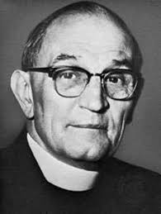

**MAUS: The Honeymoon**

What groups are targeted in the beginning of the chapter?

Why do you think this group is being persecuted?

**What groups are being targeted at the end of the chapter?**

**Based on your knowledge of history, what is a “pogrom” and why do the train passengers fear them?**

Read the poem “First they Came” and think about the events of the chapter. Who is “they” in both the chapter and the poem?

Why does the speaker regret not speaking out?