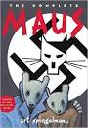

**How does Artie & Vladek’s argument about food foreshadow the events to come from Vladek’s past?**

**What historical event has led to Vladek’s capture by the Germans?**

**How are Germans drawn in the novel? Provide an example below:**

**MAUS: Prisoner of War**

**What about the ethnic Poles (Polish)? Provide an example below:**

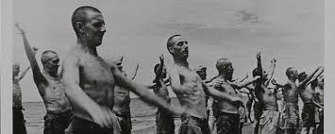

**How is Vladek able to travel back to Sosnowiecz? How is this illustrated in the chapter?**

***What is the significance of Parsha Truma*?**

List the Main Events of **Chapter 3:**