

**What was the *Gemeinde*?**

List the Main Events of **Chapter 4:**

List the examples of the Nuremburg Laws found in the chapter.

Describe the new “home” Vladek, Anja and the family are forced to move to.

**MAUS: The Noose Tightens**

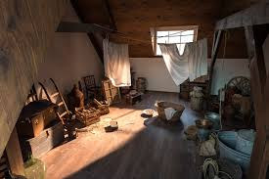

**What was *Theresensteidt* supposed to be?**

**Where were the people that were being sent there actually taken?**

**What unfortunate, ironic circumstance results from Mr. Ilzecki’s offer on pg. 83?**

***What happens to Vladek’s father and sister?***