

List the Main Events of **Chapter 5:**

The word “deported” is not used the same way today as it was used by the Third Reich during the Holocaust. How is “deportation” used in MAUS?

What happens to Richieu?

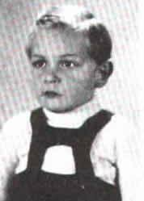

**MAUS: Mouse Holes**

***Describe the strategies Vladek uses to conceal himself and Anja during the liquidation of the ghetto.***

***How is the family discovered?***

Why does Vladek refer to his cousin who gets him out of the ghetto as a *kombinator*?

Contrast the way Vladek cares for Anja during the worst years of the war with how he treats Mala in the present.

**How is Pesach able to sell cake in the ghetto?**