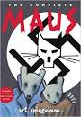

**List the MAIN Events of Chapter 6:**

**Why does Vladek think Hungary would be better than Poland?**

**Why does Art think his dad fits old stereotypes about Jewish people?**

**What other examples of anti-Semitic stereotypes are in the chapter?**

*Contrast Janina’s reaction to seeing the Spiegelmans in this chapter to how she describes them in chapter 2.*

**MAUS: Mouse Trap**

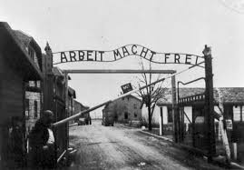

How do the Spiegelmans and Mrs. Monotowa benefit from their arrangement?

Why do Vladek & Anja hide from Mr. Monotowa?

**How are Vladek and Anja caught?**

**Who exposes them?**

**Where do they end up?**

**Based on your knowledge of history, what awaits Vladek and Anja after their arrival?**