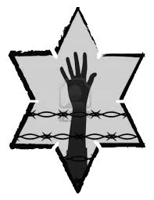

Jot Down the Main Events of **Chapter 1:**

***Describe Elie Wiesel’s father. What was his occupation?***

***Who are the other members of Elie’s family?***

Who is Moshe the Beadle? What happens to him early in the story?

When Moshe returns, how is his story received?

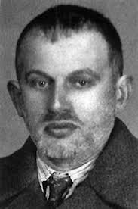

**NIGHT: Chapter 1**

Elie and his family live are members of a Jewish community in Hungary in 1944. What historical event is taking place at that time?

**Night is a first-person account of Elie Wiesel’s experience during the Holocaust. What kind of historical resource is it?**

________________________________

Who are the

**GESTAPO?**

List THREE things that happen to the Jewish community in Sighet, Hungary in Chapter 1:

1.

2.

3.