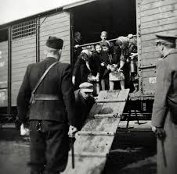

***The Wiesel family spends the majority of the chapter in a cattle car, much***

***like the one pictured to the right. Describe the conditions inside the car.***

How do the Germans treat the prisoners while they are in the cattle car?

Does this treatment affect the way the Jews behave towards each other?

Jot Down the Main Events of **Chapter 2:**

**NIGHT: Chapter 2**

**Based on your knowledge of history, what is the significance of Madame Schaecter’s visions?**

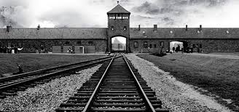

Who is Madame Schaecter?

What has happened to her that causes her behavior?

How is she treated by her fellow prisoners?

**At the end of the chapter, the train has reached its destination. Where did they go?**

The jews have been told a very significant lie about their destination. What were they told?

Why is this a lie?