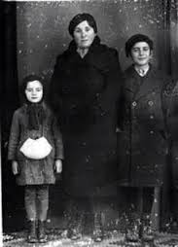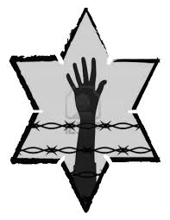

What happens to Elie’s family in the chapter?

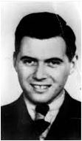

***Why does Elie say he is 18 when he is only 14?***

***Why does this encourage Elie’s father about Tzipporah’s fate?***

This is Dr. Josef Mengele. How are we introduced to him in the chapter?

What can you assume about him from the reading?

**NIGHT: Chapter 3**

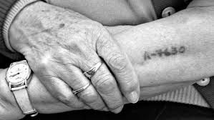

**What can you infer from the picture to the left?**

What is a KAPO?

How does Elie feel about his faith at this point in the book?

Jot Down the Main Events of **Chapter 3:**