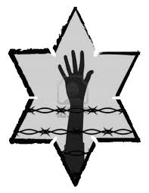

What are some items Elie has that others want when he arrives at Buna?

Why doesn’t Elie trade them away?

Jot Down the Main Events of **Chapter 4:**

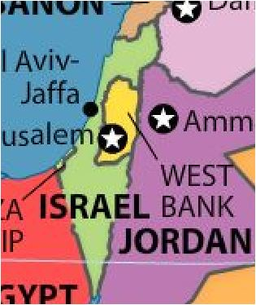

Why does Elie make plans to go to Palestine with Yossi and Tibi?

Where is Palestine?

Using your context clues, what do you think *Zionist* means?

**NIGHT: Chapter 4**

Elie makes an unexpected connection with someone at camp. Describe this person.

What is the significance of **A-7713**?

**How does Elie react to his father’s beating?**

**How do his feelings compare to his actions?**

***What incident affects Elie and the entire camp?***

***How does Elie’s faith change because of the incident?***