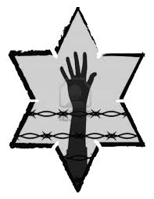

Jot Down the Main Events of **Chapter 5:**

What is the significance of the Jewish holiday Rosh Hashanah, as it is referenced in the book?

What conclusions does Elie make on this day? How do his thoughts differ from the beginning of the book?

How does this compare with what happened to Akiba Drumer?

Elie has been given many pieces of advice since he arrived at Buna. What advice is he given in Chapter 5?

What happens when he follows the advice?

**NIGHT: Chapter 5**

Elie has an operation. Even though he is being taken care of, Elie can’t relax and does not trust anyone. Why do you think this is?

What event happens while Elie is recovering?

**In a cruel twist of irony, what would have happened to Elie if he had stayed in the hospital?**

What does Elie’s father give him when his number is called?

What happens to his father?