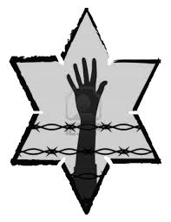

Elie and his father begin the chapter in a death march. Based on information given, how would you define a death march?

With these death marches, what have the Nazis done to Elie’s *spirit*?

Jot Down the Main Events of **Chapter 6:**

**NIGHT: Chapter 6**

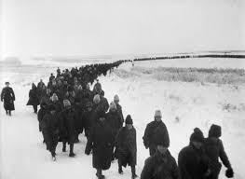

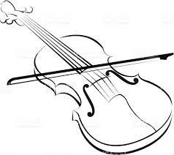

**What are the prisoners like physically and mentally when they are alone?**

**How does this change when they are together in a group?**

**The prisoners do not rise up against the Nazis, even though they outnumber the officers. This indicates that the Nazis have established…**

***"He was playing his life. The whole of his life was gliding on the strings: his lost hopes, his charred past, his extinguished future. He played as he would never play again."***

**Who is Juliek?**

**What is significant about his music?**

Why doesn’t Elie let himself fall asleep?