

Jot Down the Main Events of **Chapter 7:**

Over 100 prisoners are packed into the railcar. Elie describes the atmosphere in the car with the following quote:

***“Indifference deadened the spirit. Here or elsewhere- what difference did it make? To die today or tomorrow, or later? The night was long and never ending.”***

What is the meaning of this quote?

Is Elie referring to that actual night on the train? If not, what do you think he is referring to?

**NIGHT: Chapter 7**

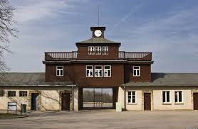

**At this point, Elie and the other prisoners haven’t eaten in 10 days. Where does the bread suddenly appear from?**

**Why do you think they did this?**

**How would you describe the prisoners’ reaction to the bread?**

**How old was Elie at the time?**

**What were you doing when you were his age?**

**Where have Elie and the prisoners gone?**

100 people were in the railcar. How many arrive at the destination?