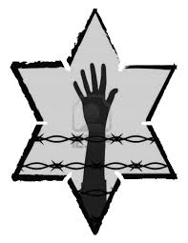

**In what ways does Elie believe he has become like Rabbi Eliahou’s son?**

**Why does he think this?**

**In this chapter, Elie and Shlomo’s relationship changes. How would you describe these changes?**

**NIGHT: Chapter 8**

In June 2009, Elie Wiesel returned to Buchenwald to give a speech on lessons he hoped the world learned from the Holocaust.

He spoke of his father’s death:

*He called my name, and I was too afraid to move. All of us were. And then he died. I was there, but I was not there.*

*And I thought one day I will come back and speak to him, and tell him of the world that has become mine.*

**What advice does the head of the block give Elie about his father?**

**Does Elie accept the advice?**

**How do his feelings compare with earlier chapters, where he and his father clung to hopes that his mother and Tzipporah were alive?**

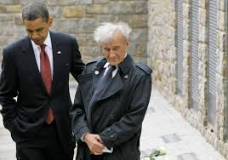

Jot Down the Main Events of **Chapter 8:**