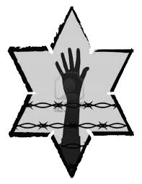

Jot Down the Main Events of **Chapter 9:**

**Describe the changes taking place in the camp in April 1945.**

**In this chapter, Elie does not give specific details about time or place. Why do you think this happens?**

**How has Elie’s father’s death affected him at this point in the book?**

**NIGHT: Chapter 9**

**What does Elie think of himself when he sees his reflection in the mirror?**



What do you think it means to be “liberated”?

Do the prisoners seek revenge when they are freed from the camps?

Will revenge undo the damage the Nazis have done to Elie and the other prisoners?

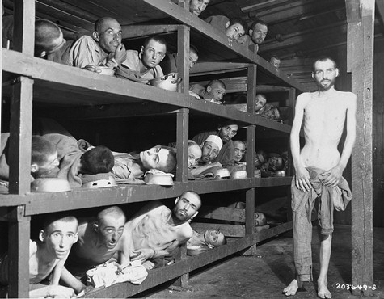

In this famous photograph of prisoners at Buchenwald concentration camp after the liberation, Elie Wiesel can be seen in the 2nd row, seventh from the left.

Approximately 6 million Jews were killed in the Holocaust, including his parents, Sarah and Shlomo, and his sister Tzipporah.

He spent his life working as a human rights advocate, telling his story so that no one would forget the horrors the Jews endured at hands of the Nazis.

Elie Wiesel died on July 2, 2016.