Directions: The first thing you need to do is use a device and Google your term plus the word ‘definition’. Then, you will need to write a complete sentence that uses the word correctly! Enjoy your learning and this is due at the END OF THE TIMED PERIOD!
Vocabulary Term: | Definition: | Sentence Use:
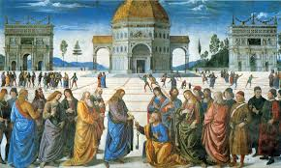
Renaissance
(re-nais-sance)
Theology
(the-o-lo-gy)
Annulment
(an-nul-ment)
Indulgences
(in-dul-gen-ces)
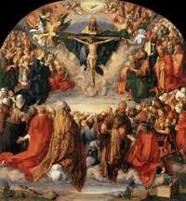
Predestination
(pre-des-ti-na-tion)
Maize
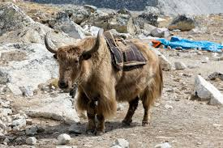
Beasts of Burden
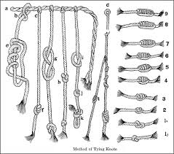
Quipu
(qui-pu)
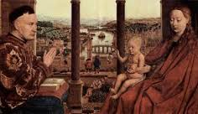
Patronage
(pa-tro-nage)
astrolabe
(as-tro-labe)
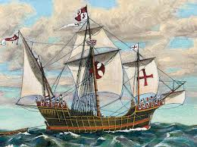
Caravel
(ca-ra-vel)
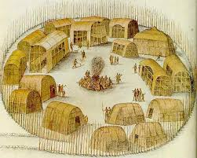
Colony
(co-lo-ny)
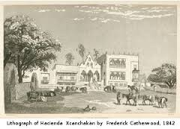
Hacienda
(ha-ci-en-da)
Indigenous
(in-di-ge-nous)
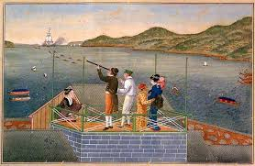
Isolationism
(i-so-la-tion-ism)
Aztecs
(az-tecs)
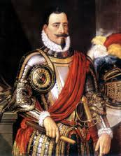
Conquistador
(con-qui-sta-dor)
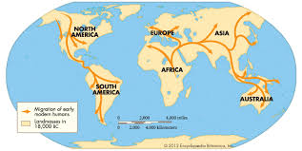
Migration
(mi-gra-tion)
Navigation
(na-vi-ga-tion)
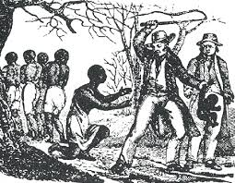
Slavery
(sla-ver-y)
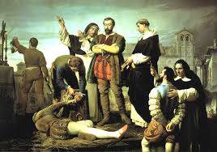
Viceroy
(vice-roy)
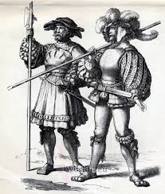
Mercenary
(mer-ce-na-ry)
Burgher
(bur-gher)
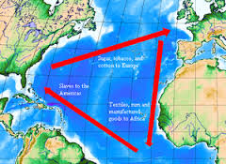
Mercantilism
(mer-can-til-ism)

