DIRECTIONS: Use Google to identify the important details, achievements, and annotations about each historical figure from the Middle Ages listed below. Remember- avoid using Wikipedia!

Historical Figure | Annotations
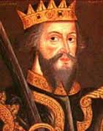William the Conqueror  Kingdom: ____________________ | Time Period: ______________________________________  Achievements: ____________________________________________________________________________ ______________________________________________________________________________________________ ______________________________________________________________________________________________ ______________________________________________________________________________________________  Notes: ______________________________________________________________________________________  ______________________________________________________________________________________________  ______________________________________________________________________________________________
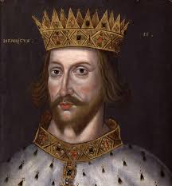  Henry II  Kingdom: ____________________ | Time Period: ______________________________________  Achievements: ____________________________________________________________________________ ______________________________________________________________________________________________ ______________________________________________________________________________________________ ______________________________________________________________________________________________  Notes: ______________________________________________________________________________________  ______________________________________________________________________________________________  ______________________________________________________________________________________________
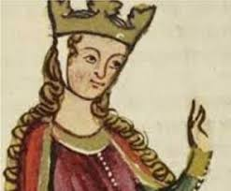  Eleanor of Aquitane  Kingdom: ____________________ | Time Period: ______________________________________  Achievements: ____________________________________________________________________________ ______________________________________________________________________________________________ ______________________________________________________________________________________________ ______________________________________________________________________________________________  Notes: ______________________________________________________________________________________  ______________________________________________________________________________________________  ______________________________________________________________________________________________
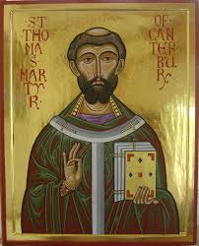  Thomas Becket  Kingdom: ____________________ | Time Period: ______________________________________  Achievements: ____________________________________________________________________________ ______________________________________________________________________________________________ ______________________________________________________________________________________________ ______________________________________________________________________________________________  Notes: ______________________________________________________________________________________  ______________________________________________________________________________________________  ______________________________________________________________________________________________
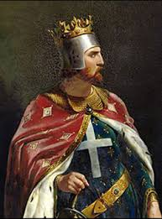  Richard I  Kingdom: ____________________ | Time Period: ______________________________________  Achievements: ____________________________________________________________________________ ______________________________________________________________________________________________ ______________________________________________________________________________________________ ______________________________________________________________________________________________  Notes: ______________________________________________________________________________________  ______________________________________________________________________________________________  ______________________________________________________________________________________________
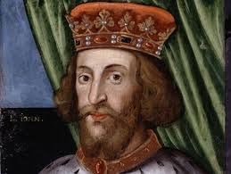  John, King of England  Kingdom: ____________________ | Time Period: ______________________________________  Achievements: ____________________________________________________________________________ ______________________________________________________________________________________________ ______________________________________________________________________________________________ ______________________________________________________________________________________________  Notes: ______________________________________________________________________________________  ______________________________________________________________________________________________  ______________________________________________________________________________________________
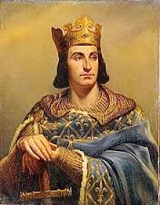  Phillip II Augustus  Kingdom: ____________________ | Time Period: ______________________________________  Achievements: ____________________________________________________________________________ ______________________________________________________________________________________________ ______________________________________________________________________________________________ ______________________________________________________________________________________________  Notes: ______________________________________________________________________________________  ______________________________________________________________________________________________  ______________________________________________________________________________________________
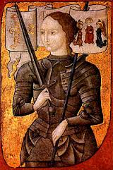  Joan of Arc  Kingdom: __________________ | Time Period: ______________________________________  Achievements: ____________________________________________________________________________ ______________________________________________________________________________________________ ______________________________________________________________________________________________ ______________________________________________________________________________________________  Notes: ______________________________________________________________________________________  ______________________________________________________________________________________________  ______________________________________________________________________________________________
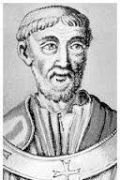  Pope Urban II  Kingdom: _________________ | Time Period: ______________________________________  Achievements: ____________________________________________________________________________ ______________________________________________________________________________________________ ______________________________________________________________________________________________ ______________________________________________________________________________________________  Notes: ______________________________________________________________________________________  ______________________________________________________________________________________________  ______________________________________________________________________________________________
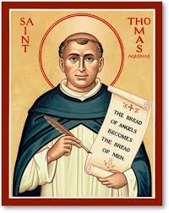  St. Thomas Aquinas  Kingdom: __________________ | Time Period: ______________________________________  Achievements: ____________________________________________________________________________ ______________________________________________________________________________________________ ______________________________________________________________________________________________ ______________________________________________________________________________________________  Notes: ______________________________________________________________________________________  ______________________________________________________________________________________________  ______________________________________________________________________________________________
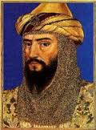  Saladin  Kingdom: ____________________ | Time Period: ______________________________________  Achievements: ____________________________________________________________________________ ______________________________________________________________________________________________ ______________________________________________________________________________________________ ______________________________________________________________________________________________  Notes: ______________________________________________________________________________________  ______________________________________________________________________________________________  ______________________________________________________________________________________________

